 |  | UNITED STATES
 | SECURITIES AND EXCHANGE COMMISSION
 |  | Washington, D.C. 20549
 |  | SCHEDULE 14A
 | Proxy Statement Pursuant to Section 14(a) of
 |  | the Securities Exchange Act of 1934
Filed by the Registrant |  | ☒
Filed by a Party other than the Registrant |  | ☐
Check the appropriate box:
- Preliminary Proxy Statement

- Confidential, for Use of the Commission Only (as permitted by Rule 14a-6(e)(2))

- Definitive Proxy Statement

- Definitive Additional Materials

- Soliciting Material under §240.14a-12

OPAL FUELS INC.

(Name of Registrant as Specified In Its Charter)

N/A

(Name of Person(s) Filing Proxy Statement, if other than the Registrant)

Payment of Filing Fee (Check all boxes that apply):

- No fee required.

- Fee paid previously with preliminary materials.

- Fee computed on table in exhibit required by Item 25(b) per Exchange Act Rules 14a-6(i)(1) and 0-11.

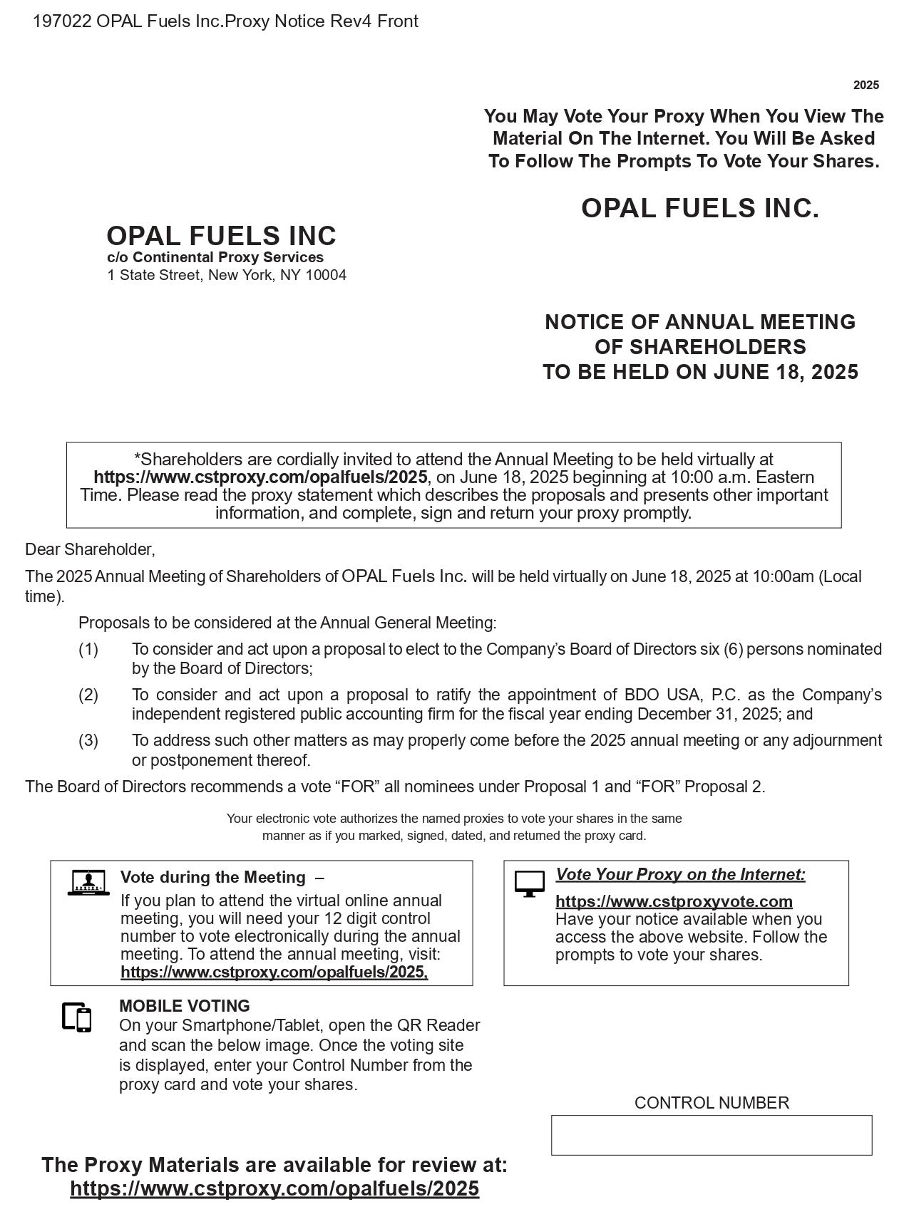

1

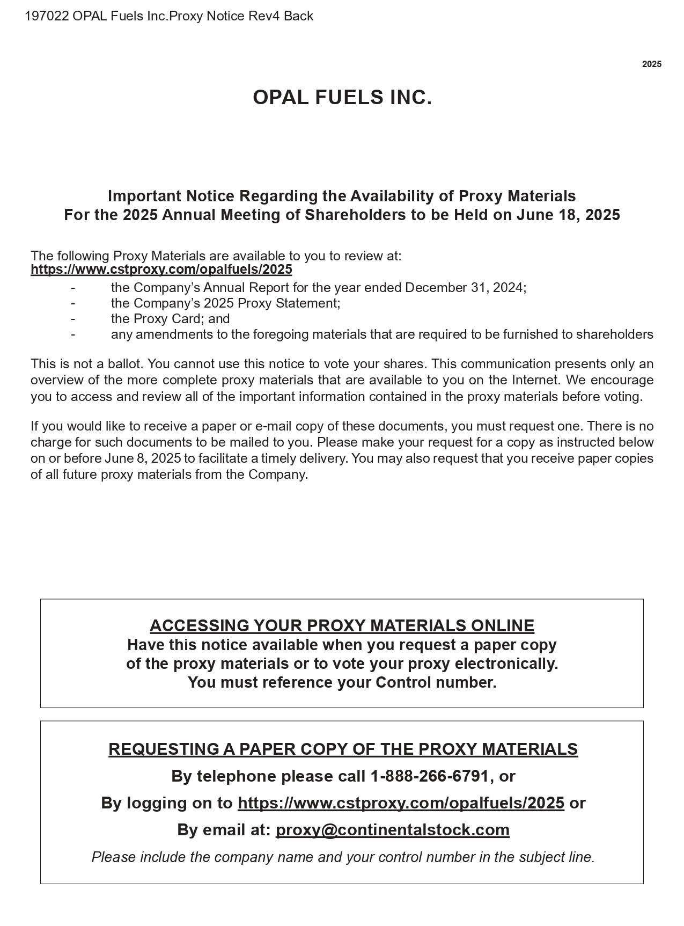

2

