SEC Form 3
FORM 3 | UNITED STATES SECURITIES AND EXCHANGE COMMISSION  Washington, D.C. 20549  INITIAL STATEMENT OF BENEFICIAL OWNERSHIP OF SECURITIES  Filed pursuant to Section 16(a) of the Securities Exchange Act of 1934  or Section 30(h) of the Investment Company Act of 1940
  OMB APPROVAL
  OMB Number: | 3235-0104
  Estimated average burden
  hours per response: | 0.5
1. Name and Address of Reporting Person*  (Street) | 2. Date of Event Requiring Statement (Month/Day/Year)  06/28/2023 | 3. Issuer Name and Ticker or Trading Symbol  OPAL Fuels Inc. [ OPAL ]
  Martell James J
  (Last) | (First) | (Middle)
  ONE NORTH LEXINGTON AVE, 14TH FLOOR
  WHITE PLAINS | NY | 10601
  (City) | (State) | (Zip)
 |  | 4. Relationship of Reporting Person(s) to Issuer  (Check all applicable) | 5. If Amendment, Date of Original Filed (Month/Day/Year)
  X | Director |  | 10% Owner
   | Officer (give title below) |  | Other (specify below)
6. Individual or Joint/Group Filing (Check Applicable Line)
X | Form filed by One Reporting Person
 | Form filed by More than One Reporting Person

Table I - Non-Derivative Securities Beneficially Owned
1. Title of Security (Instr. 4) | 2. Amount of Securities Beneficially Owned (Instr. 4) | 3. Ownership Form: Direct (D) or Indirect (I) (Instr. 5) | 4. Nature of Indirect Beneficial Ownership (Instr. 5)
Table II - Derivative Securities Beneficially Owned
(e.g., puts, calls, warrants, options, convertible securities)
1. Title of Derivative Security (Instr. 4) | 2. Date Exercisable and Expiration Date (Month/Day/Year) |  | 3. Title and Amount of Securities Underlying Derivative Security (Instr. 4) |  | 4. Conversion or Exercise Price of Derivative Security | 5. Ownership Form: Direct (D) or Indirect (I) (Instr. 5) | 6. Nature of Indirect Beneficial Ownership (Instr. 5)
1. Title of Derivative Security (Instr. 4) | Date Exercisable | Expiration Date | Title | Amount or Number of Shares | 4. Conversion or Exercise Price of Derivative Security | 5. Ownership Form: Direct (D) or Indirect (I) (Instr. 5) | 6. Nature of Indirect Beneficial Ownership (Instr. 5)
Explanation of Responses:
Remarks:
Exhibit 24.1 - Power of Attorney
No securities are beneficially owned.
 | /s/ James, Martell, J | 06/29/2023
 | ** Signature of Reporting Person | Date
Reminder: Report on a separate line for each class of securities beneficially owned directly or indirectly.
* If the form is filed by more than one reporting person, see Instruction 5 (b)(v).
** Intentional misstatements or omissions of facts constitute Federal Criminal Violations See 18 U.S.C. 1001 and 15 U.S.C. 78ff(a).
Note: File three copies of this Form, one of which must be manually signed. If space is insufficient, see Instruction 6 for procedure.
Persons who respond to the collection of information contained in this form are not required to respond unless the form displays a currently valid OMB Number.
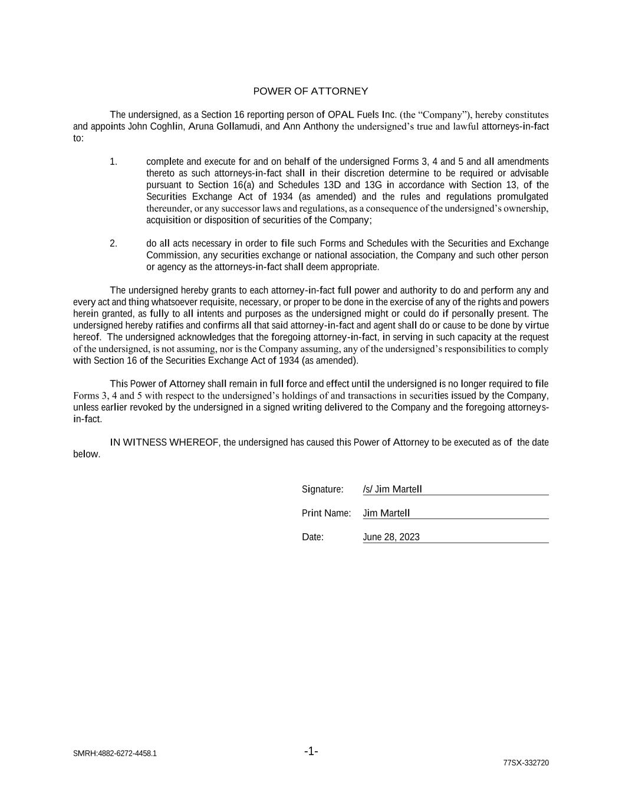
SMRH:4882-6272-4458.1 -1- 77SX-332720 POWER OF ATTORNEY The undersigned, as a Section 16 reporting person of OPAL Fuels Inc. (the “Company”), hereby constitutes and appoints John Coghlin, Aruna Gollamudi, and Ann Anthony the undersigned’s true and lawful attorneys-in-fact to: 1. complete and execute for and on behalf of the undersigned Forms 3, 4 and 5 and all amendments thereto as such attorneys-in-fact shall in their discretion determine to be required or advisable pursuant to Section 16(a) and Schedules 13D and 13G in accordance with Section 13, of the Securities Exchange Act of 1934 (as amended) and the rules and regulations promulgated thereunder, or any successor laws and regulations, as a consequence of the undersigned’s ownership, acquisition or disposition of securities of the Company; 2. do all acts necessary in order to file such Forms and Schedules with the Securities and Exchange Commission, any securities exchange or national association, the Company and such other person or agency as the attorneys-in-fact shall deem appropriate. The undersigned hereby grants to each attorney-in-fact full power and authority to do and perform any and every act and thing whatsoever requisite, necessary, or proper to be done in the exercise of any of the rights and powers herein granted, as fully to all intents and purposes as the undersigned might or could do if personally present. The undersigned hereby ratifies and confirms all that said attorney-in-fact and agent shall do or cause to be done by virtue hereof. The undersigned acknowledges that the foregoing attorney-in-fact, in serving in such capacity at the request of the undersigned, is not assuming, nor is the Company assuming, any of the undersigned’s responsibilities to comply with Section 16 of the Securities Exchange Act of 1934 (as amended). This Power of Attorney shall remain in full force and effect until the undersigned is no longer required to file Forms 3, 4 and 5 with respect to the undersigned’s holdings of and transactions in securities issued by the Company, unless earlier revoked by the undersigned in a signed writing delivered to the Company and the foregoing attorneys- in-fact. IN WITNESS WHEREOF, the undersigned has caused this Power of Attorney to be executed as of the date below. Signature: /s/ Jim Martell Print Name: Jim Martell Date: June 28, 2023

