UNITED STATES

SECURITIES AND EXCHANGE COMMISSION
Washington, D.C. 20549

FORM 8-K

CURRENT REPORT

Pursuant to Section 13 or Section 15(d)
of the Securities Exchange Act of 1934

Date of Report (Date of earliest event reported): December 2, 2021

ARCLIGHT CLEAN TRANSITION CORP. II

(Exact name of registrant as specified in its charter)

Cayman Islands

001-40272

98-1578357

(State or other jurisdiction of
incorporation or organization)

(Commission
File Number)

(IRS Employer
Identification Number)

200 Clarendon Street, 55th Floor

Boston, MA, 02116

(Address of principal executive offices)

(617) 531-6300

Registrant’s telephone number, including area code

Not Applicable

(Former name or former address, if changed since last report)

Check the appropriate box below if the Form 8-K filing is intended to simultaneously satisfy the filing obligation to the registrant under any of the following provisions:

- Written communications pursuant to Rule 425 under the Securities Act (17 CFR 230.425)

- Soliciting material pursuant to Rule 14a-12 under the Exchange Act (17 CFR 240.14a-12)

- Pre-commencement communications pursuant to Rule 14d-2(b) under the Exchange Act (17 CFR 240.14d-2(b))

- Pre-commencement communications pursuant to Rule 13e-4(c) under the Exchange Act (17 CFR 240.13e-4(c))

Securities registered pursuant to Section 12(b) of the Act:

Title of each class |  | Trading |  | Name of each exchange
 |  | Symbol(s) |  | on which registered
Units, each consisting of one Class A |  | ACTDU |  | The Nasdaq Stock Market LLC
Ordinary Share, $0.0001 par value, and
one-half of one redeemable warrant
Class A Ordinary Shares included as |  | ACTD |  | The Nasdaq Stock Market LLC
part of the units
Redeemable warrants included as part |  | ACTDW |  | The Nasdaq Stock Market LLC
of the units, each whole warrant
exercisable for one Class A Ordinary
Share at an exercise price of $11.50

Indicate by check mark whether the registrant is an emerging growth company as defined in Rule 405 of the Securities Act of 1933 or Rule 12b-2 of the Securities Exchange Act of 1934.

Emerging growth company ☒

If an emerging growth company, indicate by check mark if the registrant has elected not to use the extended transition period for complying with any new or revised financial accounting standards provided pursuant to Section 13(a) of the Exchange Act. ☐

Item 7.01. Regulation FD Disclosure.

On December 2, 2021, ArcLight Clean Transition Corp. II, an exempted company incorporated in the Cayman Islands (“ArcLight”), Opal HoldCo LLC, a Delaware limited liability company (“Opal HoldCo”), and Opal Fuels LLC, a Delaware limited liability company (“Opal”), entered into a Business Combination Agreement (as it may be amended, supplemented or otherwise modified from time to time, the “Business Combination Agreement”).

The Business Combination Agreement and the transactions contemplated thereby were unanimously approved by the boards of directors of each

of Opal and ArcLight and also approved by Opal Holdco. The Business Combination Agreement provides for, among other things, the following

transactions: (i) each outstanding Class B ordinary share of ArcLight will become one Class A ordinary share of ArcLight; (ii) ArcLight will change the

jurisdiction of its incorporation by deregistering as an exempted company in the Cayman Islands and domesticating to, and continuing as a corporation

incorporated under the laws of, the State of Delaware (the “Domestication”) and, in connection with the Domestication, (A) ArcLight’s name will be

changed to “Opal Fuels Inc.” (“New Opal”), (B) each outstanding Class A ordinary share of ArcLight will become one share of Class A Common Stock

of New Opal (the “Opal Common Stock”), (C) each outstanding warrant to purchase one Class A ordinary share of ArcLight will become a warrant to

purchase one share of Opal Common Stock and (D) New Opal will file its certificate of incorporation and adopt bylaws to serve as its governing

documents in connection with the Domestication; and (iii) (A) Opal will cause its existing limited liability company agreement to be amended and

restated, (B) Opal will cause all of its limited liability company interests existing immediately prior to the closing of the transactions contemplated by

the Business Combination Agreement (the “Closing”) to be re-classified into a number of common units (“Units”) equal to a number of Units based on a

pre-transaction equity value for Opal of an amount equal to $1,501,870,000, less all principal and accrued interest outstanding pursuant to that certain

Convertible Promissory Note, dated as of May 1, 2021, as amended from time to time, as of immediately after the Closing, (C) ArcLight will contribute

the (x) the amount of cash in the trust account established by ArcLight with the proceeds from its initial public offering (the “Trust Account”) as of

immediately prior to the Closing (and before, for the avoidance of doubt, giving effect to the exercise of redemption rights by any ArcLight shareholders

(the “ACT Share Redemptions”)), minus (y) the aggregate amount of cash required to fund the ACT Share Redemptions and any other obligations to be

funded from the Trust Account, plus (z) the aggregate cash proceeds actually received in respect of the proposed sale by ArcLight, on the date of the

Closing, of an aggregate of 12,500,000 shares of ArcLight common stock for a purchase price of $10.00 per share, for aggregate gross proceeds of

$125,000,000 to Opal in exchange for a number of units equal to the then outstanding shares of Opal Common Stock and (E) New Opal will issue to the

Company, and the Company will in turn distribute to Opal HoldCo, Hillman RNG Investments, LLC and ARCC Beacon LLC a number of Class B

Shares, par value $0.0001 per share of New Opal (the “Class B Shares”), and Class D Shares, par value $0.0001 per share of New Opal (the “Class D

Shares”) (neither of which will have any economic value but will entitle the holder thereof to one vote per share or five votes per share, as applicable),

equal to the number of Units held by each of Opal HoldCo, Hillman RNG Investments, LLC and ARCC Beacon LLC. A copy of the press release is

attached hereto as Exhibit 99.1 and incorporated herein by reference.

Attached as Exhibit 99.2 to this Current Report on Form 8-K and incorporated herein by reference is the form of presentation to be used by ArcLight in presentations for certain of ArcLight’s stockholders and other persons regarding the Business Combination Agreement. Attached as Exhibit 99.3 and incorporated by reference herein is the transcript of an investor conference call discussing the proposed business combination that was released on December 2, 2021.

The foregoing exhibits and the information set forth therein shall not be deemed to be filed for purposes of Section 18 of the Securities Exchange Act of 1934, as amended (the “Exchange Act”), or otherwise be subject to the liabilities of that section, nor shall it be deemed to be incorporated by reference in any filing under the Securities Act of 1933, as amended (the “Securities Act”), or the Exchange Act.

Important Information and Where to Find It

A full description of the terms of the transaction will be provided in a registration statement on Form S-4 to be filed with the SEC by ArcLight that will include a prospectus with respect to the combined company’s securities to be issued in connection with the business combination and a proxy statement with respect to the shareholders meeting of ArcLight to vote on the business combination. ArcLight urges its investors, shareholders and other

interested persons to read, when available, the preliminary proxy statement/prospectus as well as other documents filed with the SEC because these documents will contain important information about ArcLight, Opal and the transaction. After the registration statement is declared effective, the definitive proxy statement/prospectus to be included in the registration statement will be mailed to shareholders of ArcLight as of a record date to be established for voting on the proposed business combination. Once available, shareholders will also be able to obtain a copy of the S-4, including the proxy statement/prospectus, and other documents filed with the SEC without charge, by directing a request to: ArcLight Clean Transition Corp. II, 200 Clarendon Street, 55th Floor, Boston, Massachusetts 02116. The preliminary and definitive proxy statement/prospectus to be included in the registration statement, once available, can also be obtained, without charge, at the SEC’s website (www.sec.gov).

Participants in the Solicitation

ArcLight and Opal and their respective directors and officers may be deemed to be participants in the solicitation of proxies from ArcLight’s shareholders in connection with the proposed transaction. Information about ArcLight’s directors and executive officers and their ownership of ArcLight’s securities is set forth in ArcLight’s filings with the SEC. To the extent that holdings of ArcLight’s securities have changed since the amounts printed in ArcLight’s Registration Statement on Form S-1, such changes have been or will be reflected on Statements of Change in Ownership on Form 4 filed with the SEC. Additional information regarding the interests of those persons and other persons who may be deemed participants in the proposed transaction may be obtained by reading the proxy statement/consent solicitation statement/prospectus regarding the proposed transaction when it becomes available. You may obtain free copies of these documents as described in the preceding paragraph.

Forward Looking Statements

Certain statements included in this Form 8-K may be considered forward-looking statements. Forward-looking statements are statements that are not historical facts and generally relate to future events or ArcLight’s or Opal’s future financial or other performance metrics. In some cases, you can identify forward-looking statements by terminology such as “believe,” “may,” “will,” “potentially,” “estimate,” “continue,” “anticipate,” “intend,” “could,” “would,” “project,” “target,” “plan,” “expect,” or the negatives of these terms or variations of them or similar terminology. Such forward-looking statements, including the identification of a target business and a potential business combination or other such transaction are subject to risks and uncertainties, which could cause actual results to differ materially from those expressed or implied by such forward looking statements. New risks and uncertainties may emerge from time to time, and it is not possible to predict all risks and uncertainties. These forward-looking statements are based upon estimates and assumptions that, while considered reasonable by ArcLight and its management, and Opal and its management, as the case may be, are inherently uncertain and subject to material change. Factors that may cause actual results to differ materially from current expectations include, but are not limited to, various factors beyond management’s control, including general economic conditions and other risks, uncertainties and factors set forth in the section entitled “Risk Factors” and “Cautionary Note Regarding Forward-Looking Statements” in ArcLight’s final prospectus relating to its initial public offering, dated September 22, 2020, and other filings with the Securities and Exchange Commission (SEC), including the registration statement on Form S-4 to be filed by ArcLight in connection with the proposed business combination, as well as (1) the inability to complete the proposed business combination; (2) the failure to realize the anticipated benefits of the proposed business combination, which may be affected by, among other things, competition, the ability of the combined company to grow and manage growth profitably, maintain relationships with customers and suppliers and retain key employees; (3) delays in obtaining, adverse conditions contained in, or the inability to obtain necessary regulatory approvals or complete regulatory reviews required to complete the proposed business combination; (4) the outcome of any legal proceedings that may be instituted in connection with the proposed business combination; the inability to complete the proposed business combination; (5) macroeconomic conditions related to the global COVID-19 pandemic; (6) factors associated with companies, such as Opal, that are engaged in the production and integration of renewable natural gas (RNG), including anticipated trends, growth rates and challenges in those businesses and in the markets in which they operate; (7) the effects of increased competition; (8) contractual arrangements with, and the cooperation of, landfill and livestock waste site owners and operators, on which Opal operates its landfill gas and livestock waste projects that generate electricity and RNG prices for environmental attributes, low carbon fuel standard credits and other incentives; (9) the ability to identify, acquire, develop and operate renewable projects and RNG fueling stations; (10) the amount of redemption requests made by

ArcLight’s public shareholders; and (11) the ability of the combined company to issue equity or equity-linked securities or obtain debt financing in connection with the transaction or in the future. Nothing in this Form 8-K should be regarded as a representation by any person that the forward-looking statements set forth herein will be achieved or that any of the contemplated results of such forward-looking statements will be achieved. You should not place undue reliance on forward-looking statements in this Form 8-K, which speak only as of the date they are made and are qualified in their entirety by reference to the cautionary statements herein. Both ArcLight and Opal expressly disclaim any obligations or undertaking to release publicly any updates or revisions to any forward-looking statements contained herein to reflect any change in ArcLight’s or Opal’s expectations with respect thereto or any change in events, conditions or circumstances on which any statement is based.

Non-Solicitation

This Form 8-K is not a proxy statement or solicitation of a proxy, consent or authorization with respect to any securities or in respect of the potential transaction and shall not constitute an offer to sell or a solicitation of an offer to buy the securities of ArcLight, Opal or the combined company, nor shall there be any sale of any such securities in any state or jurisdiction in which such offer, solicitation, or sale would be unlawful prior to registration or qualification under the securities laws of such state or jurisdiction. No offer of securities shall be made except by means of a prospectus meeting the requirements of the Securities Act.

Item 9.01. Financial Statements and Exhibits.

- Exhibits

Exhibit
No. Description

99.1 Press Release, dated December 2, 2021.

99.2 Investor Presentation.

99.3 Investor Call Transcript.

104 Cover Page Interactive Data File - the cover page XBRL tags are embedded within the Inline XBRL document

SIGNATURE

Pursuant to the requirements of the Securities Exchange Act of 1934, the registrant has duly caused this report to be signed on its behalf by the undersigned hereunto duly authorized.

Dated: December 2, 2021

ARCLIGHT CLEAN TRANSITION CORP. II

By: /s/ John F. Erhard

Name: John F. Erhard

Title: President and Chief Executive Officer

Exhibit 99.1

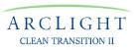

FOR IMMEDIATE RELEASE

OPAL Fuels, a Leading Vertically Integrated Producer and

Distributor of Renewable Natural Gas, to List on Nasdaq through

Combination with ArcLight Clean Transition Corp. II

- OPAL Fuels LLC has entered into a business combination agreement with ArcLight Clean Transition Corp. II (Nasdaq: ACTD) (“ArcLight”) with an enterprise value of $1.75 billion; upon closing, the combined company will be listed on the Nasdaq Exchange under the ticker symbol “OPL”.

- OPAL Fuels is a leading vertically integrated producer and distributor of renewable natural gas (“RNG”) with a diversified revenue and customer base in 42 states.

- Transaction includes a $125 million fully committed common stock PIPE at $10.00 per share anchored by NextEra Energy, Inc. (NYSE: NEE) (“NextEra Energy”), Electron Capital Partners, Gunvor Group, Wellington Management and Adage Capital Management, with participation by ArcLight affiliates.

- Additionally, affiliates of NextEra Energy have made a commitment for up to a $100 million preferred equity investment in OPAL Fuels and have entered into a purchase and sale agreement for the majority of OPAL Fuels environmental attributes.

- Assuming no redemptions, the transactions are expected to provide gross proceeds of approximately $536 million to fund the construction of OPAL Fuels’ robust RNG development pipeline.

WHITE PLAINS, N.Y. – (December 2, 2021) – OPAL Fuels LLC (“OPAL Fuels” or the “Company”), a leading vertically integrated producer and distributor of renewable natural gas (RNG), and ArcLight Clean Transition Corp. II (Nasdaq: ACTD) (“ArcLight”), a publicly-traded special purpose acquisition company, announced today a definitive agreement for a business combination that will result in OPAL Fuels becoming a publicly listed company. Upon closing of the transaction, the combined company will be named OPAL Fuels Inc. and remain listed on the Nasdaq Stock Exchange under the new ticker symbol “OPL.” The combined company will continue to be led by OPAL Fuels co-CEOs Adam Comora and Jonathan Maurer.

RNG is a proven low-cost, low-carbon fuel that when used in transportation in place of diesel fuel can cost 40 to 70 percent less per gallon, providing significant annual operating cost savings while dramatically reducing the carbon footprint of heavy duty fleets.

-1-

OPAL Fuels, a FORTISTAR portfolio company, is a vertically integrated, waste-to-fuel RNG production and distribution company with a Capture and Conversion upstream business and Dispensing and Monetization downstream business serving the domestic heavy duty transportation sector. Underpinned by gas rights agreements that are typically at least twenty years in length, Capture and Conversion projects produce RNG by capturing methane emissions from landfill sites and dairy farms. The captured methane emissions are purified and treated, turning once harmful emissions into a source of clean, renewable energy, reducing the harmful long-term effects of methane and carbon emissions. This flips a substantial cost – managing dairy waste and landfill gas – into significant revenue streams for dairy farms and landfills. OPAL Fuels’ Dispensing and Monetization operations help deliver this clean, reliable and renewable fuel to heavy duty trucking fleets through OPAL Fuels’ national network of fueling stations, which spans 42 states and is typically backed by fueling agreements averaging ten years in duration.

OPAL Fuels is also positioned for a future that includes the commercialization of emerging technologies, including renewable hydrogen, through existing partnerships with key industry participants. The company is well placed to be an enabler of renewable hydrogen that uses RNG in its production and to develop, construct, and operate heavy duty hydrogen fueling station networks.

OPAL Fuels has a proven business model, tracing its roots back to 1998, and is expected to generate nearly $170 million in revenues in 2021. The company’s vertically integrated model benefits its margin profile and positions the company well to capture share in a fragmented industry that is characterized by smaller, non-vertically integrated upstream and downstream participants.

Today, OPAL Fuels operates 21 biomethane projects, of which three are in RNG service and the balance are in renewable power service. Increasing secular tailwinds, which include public policy initiatives and corporate sustainability objectives, are supporting the growth of RNG as a way to cost effectively halt climate change and decarbonize transportation, providing strong visibility into significant volume and EBITDA growth for OPAL Fuels over the next several years. The company’s project pipeline totals 23, seven of which are in construction and the balance of which are in advanced development execution.

Management Commentary

Adam Comora, co-CEO of OPAL Fuels, stated, “This transaction with ArcLight reflects a transformative step in our company’s development and strategy. RNG powered heavy duty fleets realize substantial savings today versus diesel and the successful execution of our robust growth plans will expand the role of ultra low-carbon RNG across the transportation sector. By capturing harmful fugitive methane emissions and replacing traditional fossil fuel usage, we will advance the sustainability and decarbonization goals of public policy makers, our customers and our

-2-

partners across the nation. RNG is a right now solution to the right now problem of climate change. RNG is one of the most attractive sources of renewable energy – its production uses existing technologies proven at scale, it can be transported on existing pipeline infrastructure, and it can be stored effectively until its use, all of which lead to a cost competitive and reliable fuel source. We are thrilled to partner with ArcLight, as we believe their experience as a leading energy infrastructure asset manager is a strong vote of confidence in the bright future of our company. We look forward to leveraging their expertise as we execute on our business model.”

Jonathan Maurer, co-CEO of OPAL Fuels, commented, “It is an incredibly exciting time at OPAL Fuels. The market for RNG as a transportation fuel is at an inflection point, and we are excited to leverage our expertise in renewable power to be a leader in RNG projects as we convert renewable power projects to renewable transportation fuel facilities. Our seasoned team, which includes several leaders that have more than 25 years of experience in the industry, is excited to execute on our robust project pipeline and deliver value to all of our stakeholders.”

Jake Erhard, President and CEO of ArcLight Clean Transition Corp. II said, “OPAL Fuels is a leading platform for the production and distribution of ultra low-carbon RNG to the transportation sector, the highest value end-market for RNG. The company’s vertically integrated model differentiates it from other players in the industry, which together with the platform’s more than two decades of experience gives us tremendous confidence in the company’s ability to execute its growth plans. Importantly, OPAL Fuels’ business contributes meaningfully to sustainable development in the transportation, waste management and agricultural industries by enabling the adoption of leading-edge methane capture technologies and processes that drastically reduce greenhouse gas emissions.”

John Ketchum, President and CEO of NextEra Energy Resources, said, “We’re excited about this opportunity with OPAL Fuels to leverage renewable natural gas to produce and distribute ultra low-carbon fuels that are helping drive decarbonization of the transportation sector. This investment is consistent with our strategy to help lead the decarbonization of the transportation, electricity and industrial sectors in the U.S.”

Transaction Overview

The business combination values OPAL Fuels at an implied $1.75 billion pro forma enterprise value at a price of $10.00 per ArcLight share. The transaction and related financings are expected to provide gross proceeds of approximately $536 million to OPAL Fuels, comprised of:

- ArcLight’s $311 million of cash held in trust, assuming no redemptions,

- A $125 million fully committed PIPE, anchored by NextEra Energy, an affiliate of ArcLight, Electron Capital Partners, Gunvor Group, Wellington Management and Adage Capital Management, and;

- Up to a $100 million preferred equity investment from affiliates of NextEra Energy.

-3-

The boards of directors of both ArcLight Clean Transition Corp. II and OPAL Fuels have approved the proposed transaction, which is expected to be completed in the second quarter of 2022, subject to, among other things, approval by ArcLight’s stockholders and satisfaction or waiver of other conditions stated in the definitive documentation.

Additional information about the proposed transaction, including a copy of the merger agreement and investor presentation, will be provided in a Current Report on Form 8-K to be filed by ArcLight with the Securities and Exchange Commission and available at https://www.sec.gov/.

Advisors

BofA Securities, Inc. (“BofA Securities”) is serving as lead financial advisor and Credit Suisse Securities (USA) LLC (“Credit Suisse”) is serving as financial advisor while Sheppard Mullin Richter & Hampton LLP is serving as legal advisor to OPAL Fuels. Citigroup Global Markets Inc. (“Citi”) is serving as lead financial advisor and Barclays Capital Inc. (“Barclays”) is serving as financial advisor while Kirkland & Ellis LLP is serving as legal advisor to ArcLight. Citi, BofA Securities, Barclays and Credit Suisse are serving as joint placement agents on the PIPE offering, while Winston & Strawn LLP is counsel to the Placement Agents. J.P. Morgan Securities LLC served as sole financial advisor and Hogan Lovells US LLP acted as counsel to NextEra Energy on the transaction.

Investor Conference Call Information

OPAL Fuels and ArcLight will host a joint investor conference call at 8:30 AM ET today, December 2, 2021, to discuss the proposed transaction. To listen to the prepared remarks via telephone dial 1-877-407-3982 (U.S.) or 1-201-493-6780 (International) and an operator will assist you. A telephone replay will be available at 1-844-512-2921(U.S.) or 1-412-317-6671 (International), PIN: 13725376 through December 16, 2021 at 11:59 PM ET. A transcript of this conference call can also be found on OPAL Fuels’ Investor page and will be filed by ArcLight with the SEC.

About OPAL Fuels LLC

OPAL Fuels LLC, a FORTISTAR portfolio company, is a leading vertically integrated renewable fuels platform involved in the production and distribution of renewable natural gas (RNG) for the heavy-duty truck market. RNG is a proven low carbon fuel that is rapidly decarbonizing the transportation industry now while also significantly reducing costs for fleet owners. OPAL Fuels captures harmful methane emissions at the source and recycles the trapped energy into a commercially viable, low-cost alternative to diesel fuel. OPAL Fuels also develops and constructs RNG fueling stations. As a producer and distributor of carbon-reducing fuel for heavy-duty truck

-4-

fleets for over 15 years, the company delivers best-in-class, complete renewable solutions to customers and production partners. To learn more about OPAL Fuels and how it is leading the effort to capture North America’s harmful methane emissions and decarbonize the transportation industry, please visit www.opalfuels.com and follow the company on LinkedIn and Twitter at @OPALFuels.

About ArcLight Clean Transition Corp. II

ArcLight, ArcLight Clean Transition Corp. II, led by Chairman Daniel Revers and President and Chief Executive Officer Jake Erhard, is a special purpose acquisition company formed for the purpose of effecting a capital stock exchange, asset acquisition, share purchase, reorganization, or similar business combination with one or more businesses focused on opportunities created by the accelerating transition toward sustainable use of energy and natural resources.

About FORTISTAR

Founded in 1993, FORTISTAR is a privately-owned investment firm that provides capital to build, grow and manage companies that address complex sustainability challenges. FORTISTAR utilizes its capital, flexibility and operating expertise to grow high-performing assets, first in independent power projects and now into other areas that support decarbonization. For more information about FORTISTAR or its portfolio companies, please visit: www.fortistar.com and follow the company on LinkedIn.

Forward-Looking Statements

Certain statements in this communication may be considered forward-looking statements. Forward-looking statements are statements that are not historical facts and generally relate to future events or ArcLight’s or the Company’s future financial or other performance metrics. In some cases, you can identify forward-looking statements by terminology such as “believe,” “may,” “will,” “potentially,” “estimate,” “continue,” “anticipate,” “intend,” “could,” “would,” “project,” “target,” “plan,” “expect,” or the negatives of these terms or variations of them or similar terminology. Such forward-looking statements, including the identification of a target business and a potential business combination or other such transaction are subject to risks and uncertainties, which could cause actual results to differ materially from those expressed or implied by such forward looking statements. New risks and uncertainties may emerge from time to time, and it is not possible to predict all risks and uncertainties. These forward-looking statements are based upon estimates and assumptions that, while considered reasonable by ArcLight and its management, and the Company and its management, as the case may be, are inherently uncertain and subject to material change. Factors that may cause actual results to differ materially from current expectations include, but are not limited to, various factors beyond management’s control, including general economic conditions and other risks, uncertainties and factors set forth in the section entitled “Risk Factors” and “Cautionary Note Regarding Forward-Looking Statements” in ArcLight’s final prospectus relating to its initial public offering, dated September 22, 2020, and other filings with the Securities and Exchange Commission (SEC), including the registration statement on Form S-4 to be filed by ArcLight in connection with the transaction, as well as (1) the inability to complete the proposed transaction; (2) factors associated with companies, such as the Company, that are engaged in the production and integration of renewable natural gas (RNG),

-5-

including anticipated trends, growth rates, and challenges in those businesses and in the markets in which they operate; (3) macroeconomic conditions related to the global COVID-19 pandemic; (4) the effects of increased competition; (5) contractual arrangements with, and the cooperation of, landfill and livestock waste site owners and operators, on which the Company operates its landfill gas and livestock waste projects that generate electricity and RNG prices for environmental attributes, low carbon fuel standard credits and other incentives; (6) the ability to identify, acquire, develop and operate renewable projects and RNG fueling stations; (7) the failure to realize the anticipated benefits of the proposed transaction, which may be affected by, among other things, competition, the ability of the combined company to grow and manage growth profitably, maintain relationships with customers and suppliers and retain key employees; (8) delays in obtaining, adverse conditions contained in, or the inability to obtain necessary regulatory approvals or complete regulatory reviews required to complete the proposed transaction; (9) the outcome of any legal proceedings that may be instituted in connection with the proposed transaction; (10) the amount of redemption requests made by ArcLight’s public shareholders; and (11)the ability of the combined company that results from the proposed transaction to issue equity or equity-linked securities or obtain debt financing in connection with the transaction or in the future. Nothing in this communication should be regarded as a representation by any person that the forward-looking statements set forth herein will be achieved or that any of the contemplated results of such forward-looking statements will be achieved. You should not place undue reliance on forward-looking statements in this communication, which speak only as of the date they are made and are qualified in their entirety by reference to the cautionary statements herein. Both ArcLight and the Company expressly disclaim any obligations or undertaking to release publicly any updates or revisions to any forward-looking statements contained herein to reflect any change in ArcLight’s or the Company’s expectations with respect thereto or any change in events, conditions or circumstances on which any statement is based.

Important Information and Where to Find It

A full description of the terms of the transaction will be provided in a registration statement on Form S-4 to be filed with the SEC by ArcLight that will include a prospectus with respect to the combined company’s securities to be issued in connection with the business combination and a proxy statement with respect to the shareholders meeting of ArcLight to vote on the business combination. ArcLight urges its investors, shareholders and other interested persons to read, when available, the preliminary proxy statement/prospectus as well as other documents filed with the SEC because these documents will contain important information about ArcLight, the Company and the transaction. After the registration statement is declared effective, the definitive proxy statement/prospectus to be included in the registration statement will be mailed to shareholders of ArcLight as of a record date to be established for voting on the proposed business combination. Once available, shareholders will also be able to obtain a copy of the S-4, including the proxy statement/prospectus, and other documents filed with the SEC without charge, by directing a request to: ArcLight Clean Transition Corp. II, 200 Clarendon Street, 55th Floor, Boston, Massachusetts 02116. The preliminary and definitive proxy statement/prospectus to be included in the registration statement, once available, can also be obtained, without charge, at the SEC’s website (www.sec.gov).

-6-

Participants in the Solicitation

ArcLight and the Company and their respective directors and officers may be deemed to be participants in the solicitation of proxies from ArcLight’s shareholders in connection with the proposed transaction. Information about ArcLight’s directors and executive officers and their ownership of ArcLight’s securities is set forth in ArcLight’s filings with the SEC. To the extent that holdings of ArcLight’s securities have changed since the amounts printed in ArcLight’s Registration Statement on Form S-1, such changes have been or will be reflected on Statements of Change in Ownership on Form 4 filed with the SEC. Additional information regarding the interests of those persons and other persons who may be deemed participants in the proposed transaction may be obtained by reading the proxy statement/consent solicitation statement/prospectus regarding the proposed transaction when it becomes available. You may obtain free copies of these documents as described in the preceding paragraph.

Non-Solicitation

This communication is not a proxy statement or solicitation of a proxy, consent or authorization with respect to any securities or in respect of the potential transaction and shall not constitute an offer to sell or a solicitation of an offer to buy the securities of ArcLight, the Company or the combined company, nor shall there be any sale of any such securities in any state or jurisdiction in which such offer, solicitation, or sale would be unlawful prior to registration or qualification under the securities laws of such state or jurisdiction. No offer of securities shall be made except by means of a prospectus meeting the requirements of the Securities Act.

Contact information

OPAL Fuels

Investors

ICR, Inc.

OPALFuelsIR@icrinc.com

Media

Jason Stewart

Senior Director Public Relations and Marketing

914-421-5336

jstewart@opalfuels.com

ICR, Inc.

OPALFuelsPR@icrinc.com

ArcLight Clean Transition Corp. II

Marco Gatti

Chief Financial Officer

617-531-6300

investor.relations@arclightclean.com

-7-



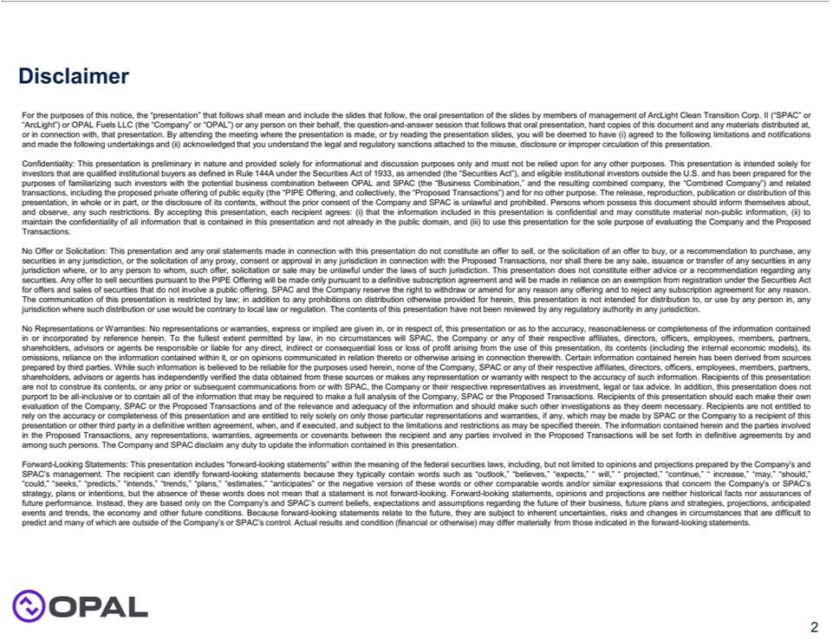

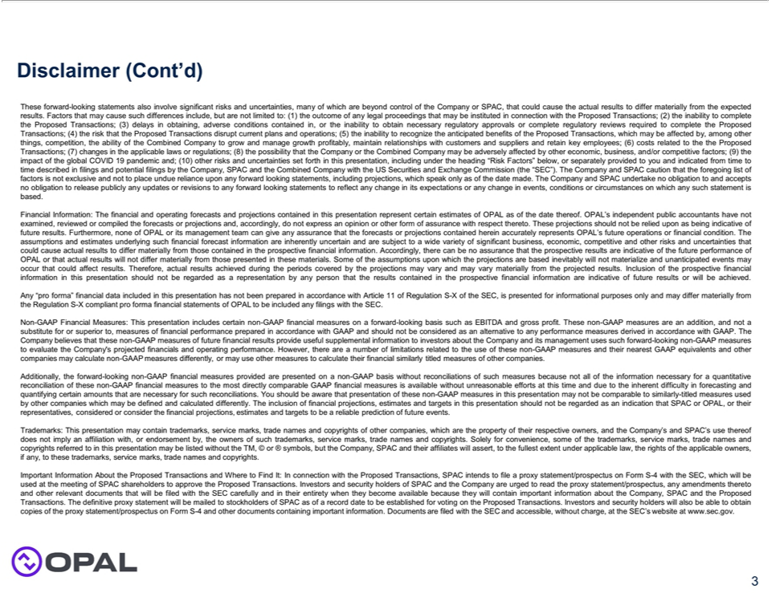

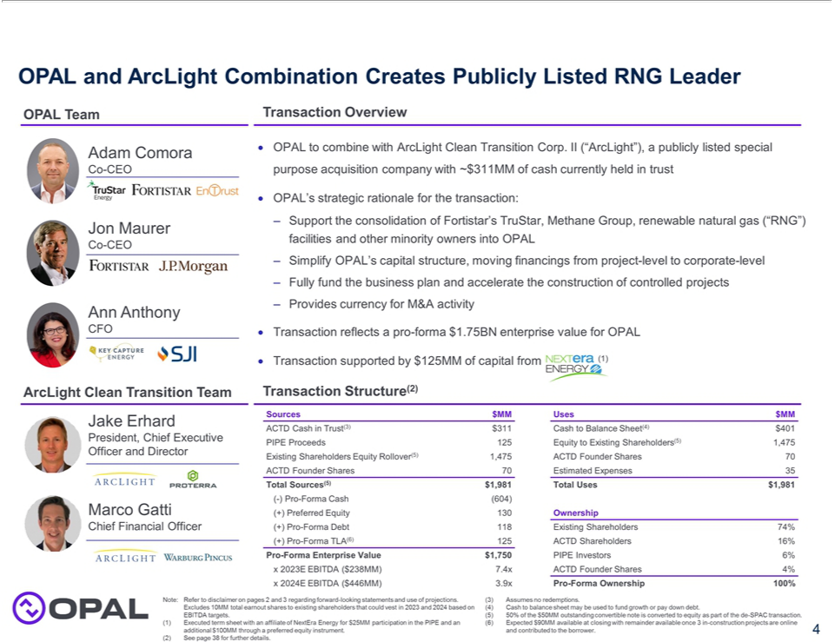

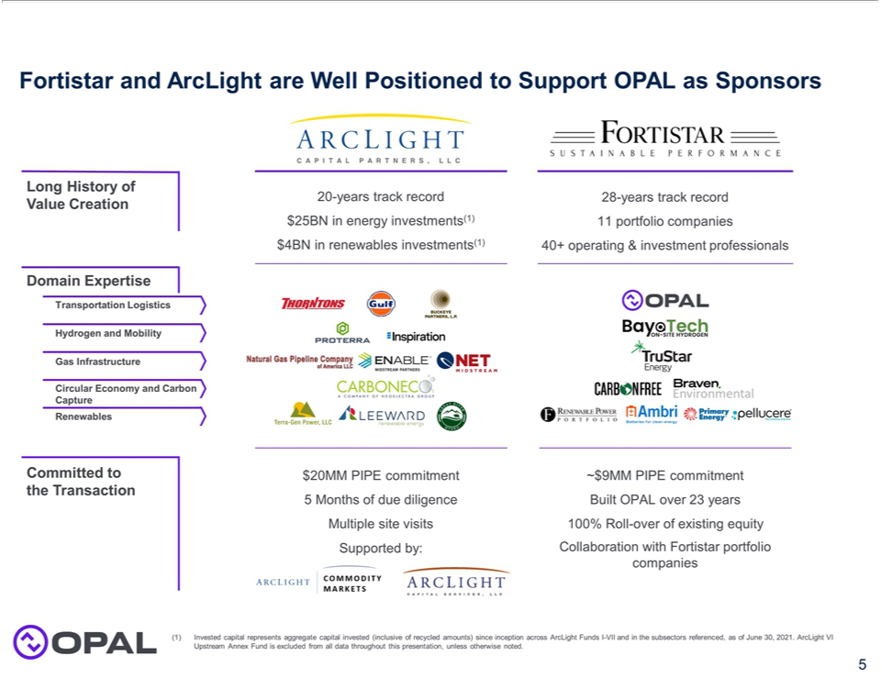

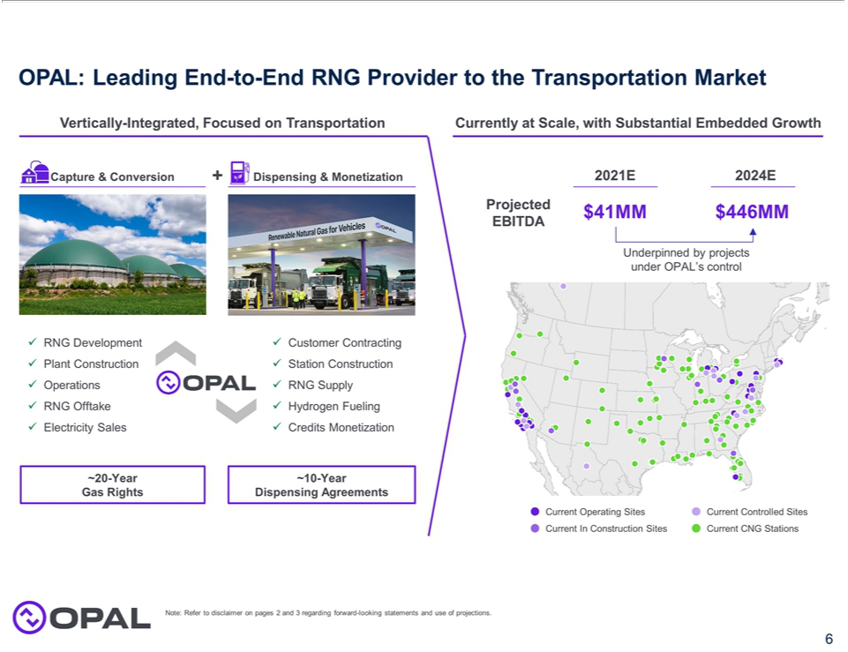

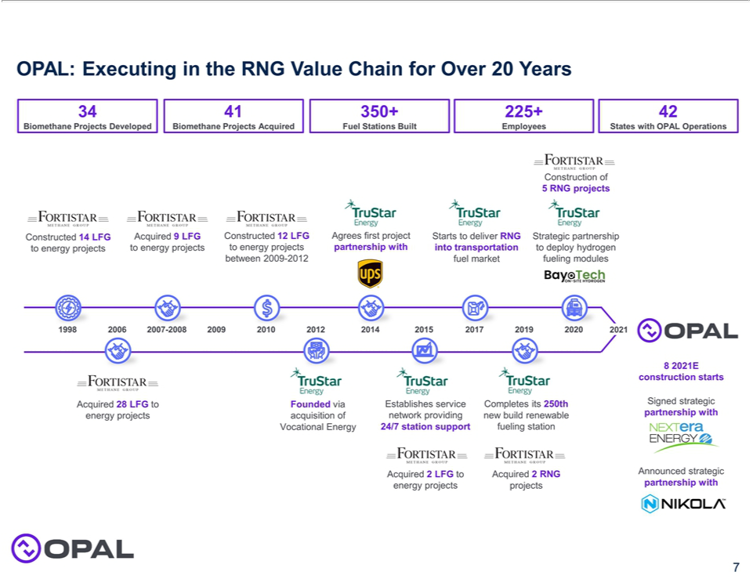

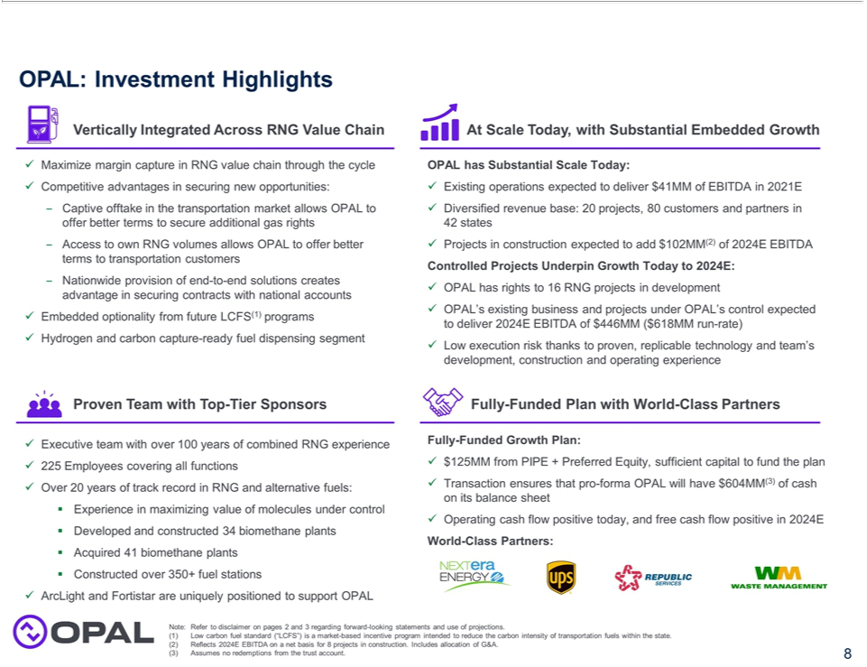



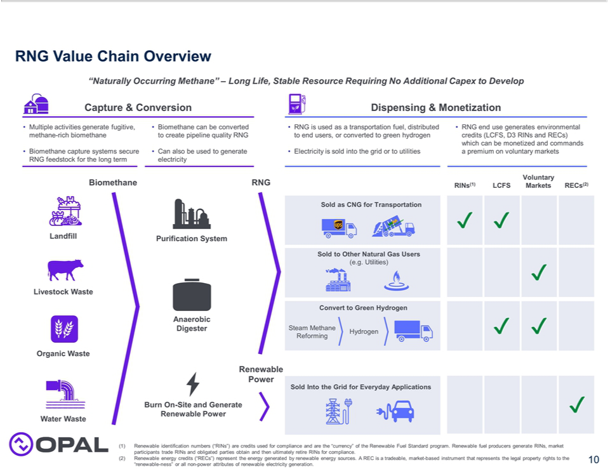

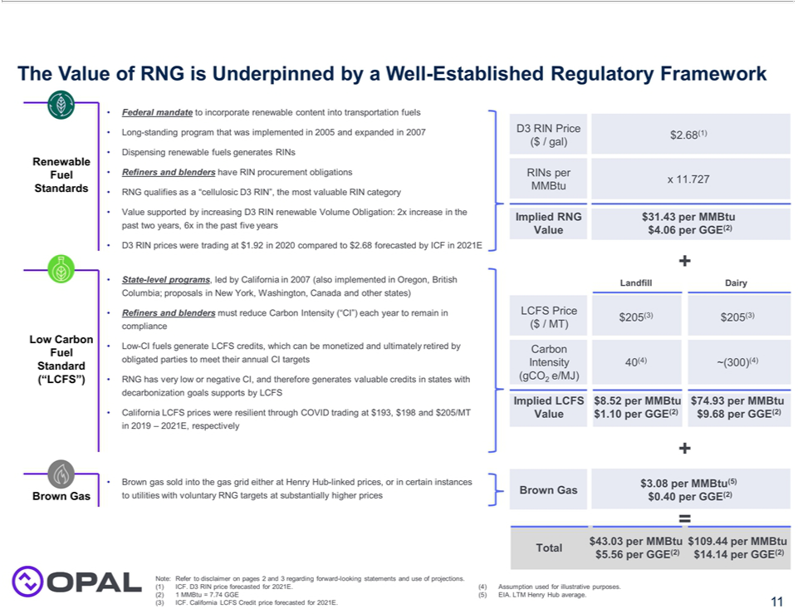

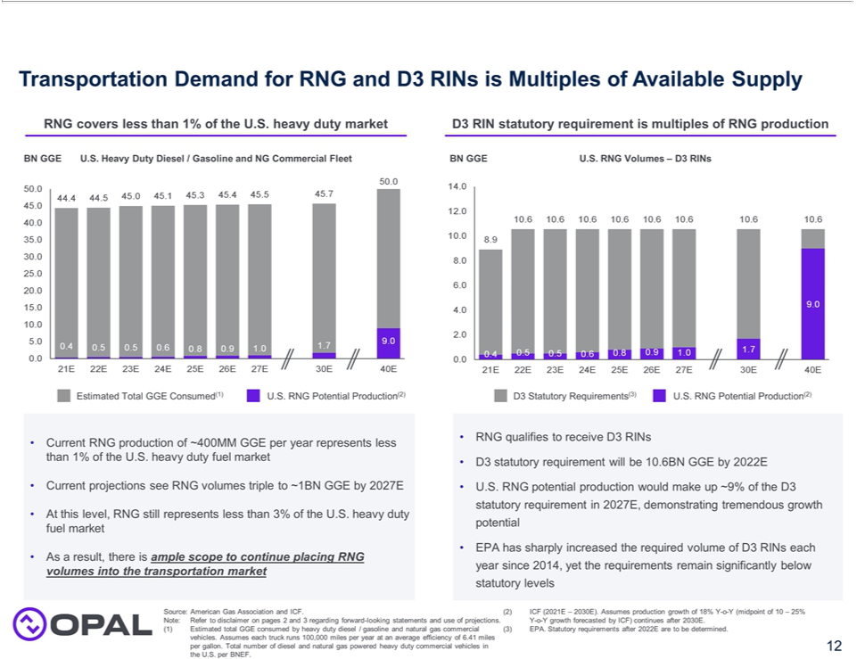

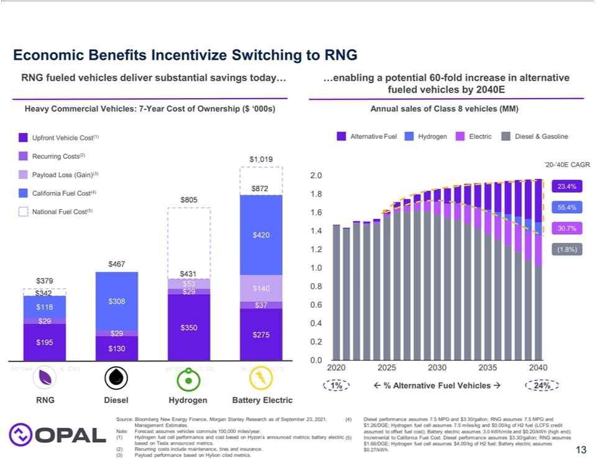

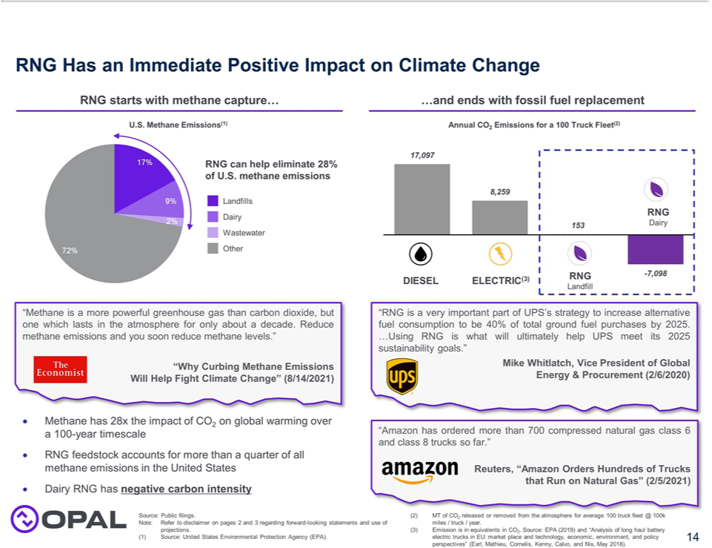



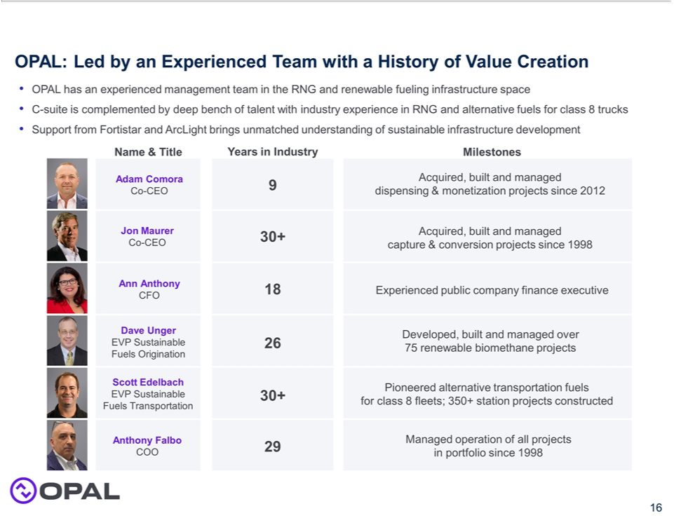

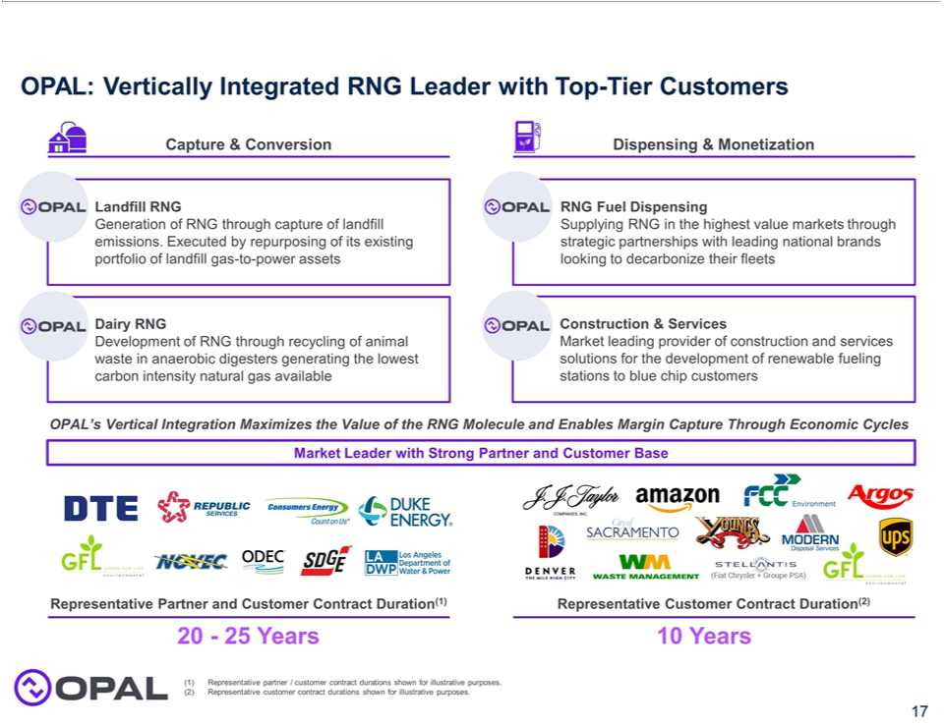

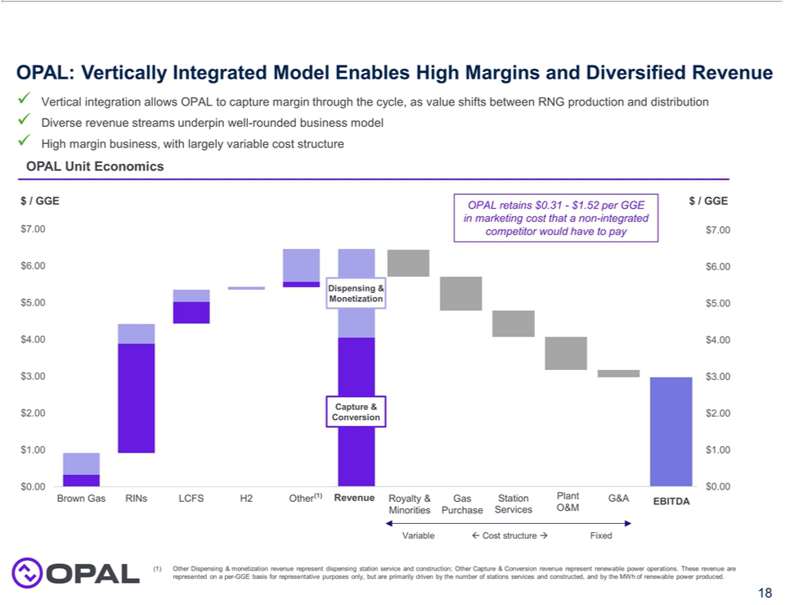

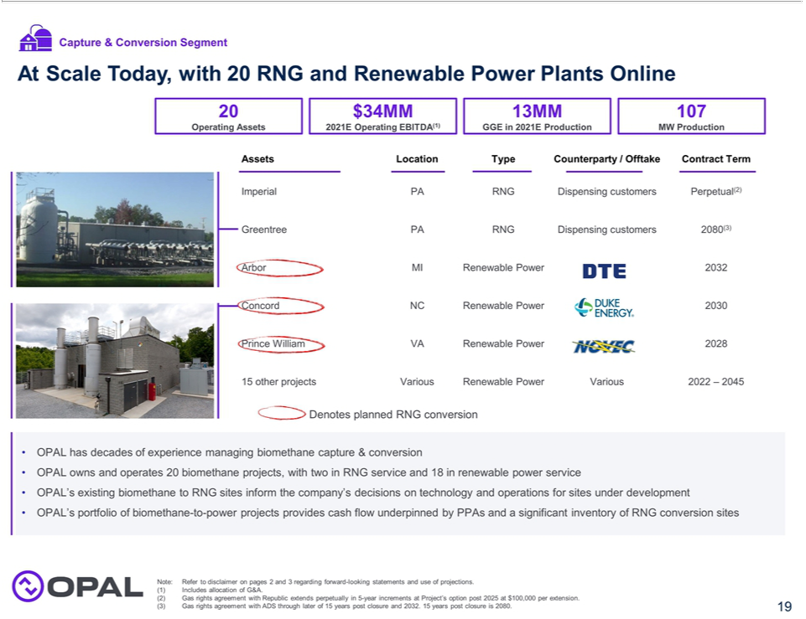

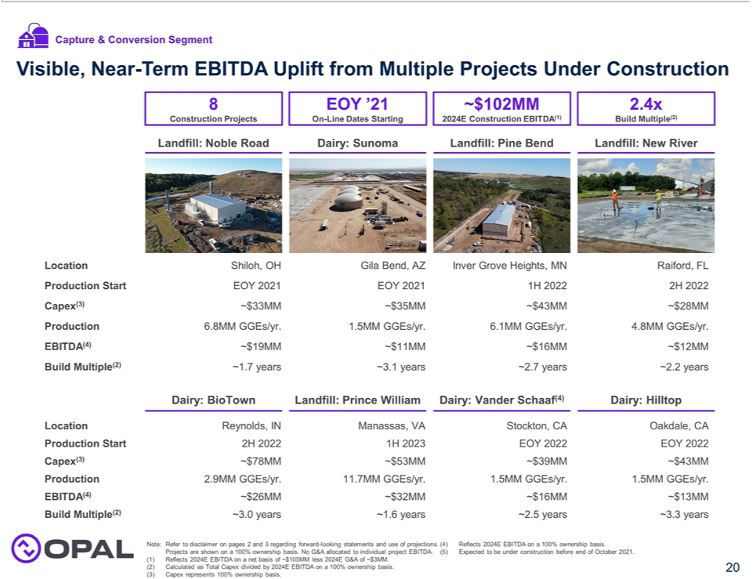

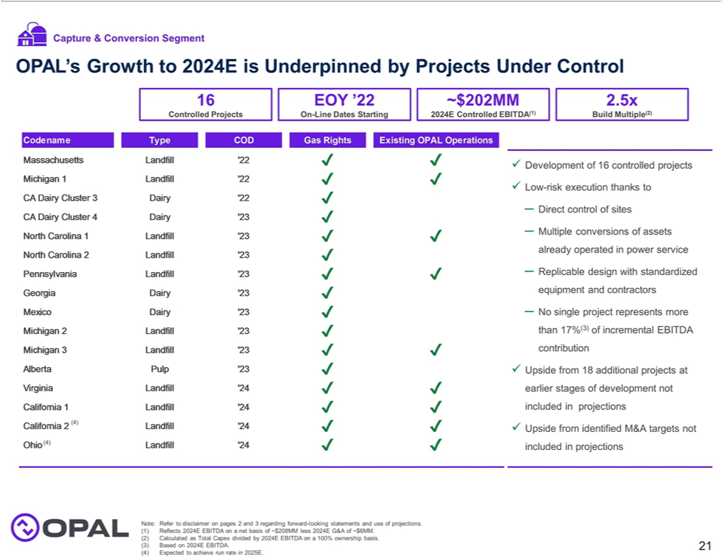

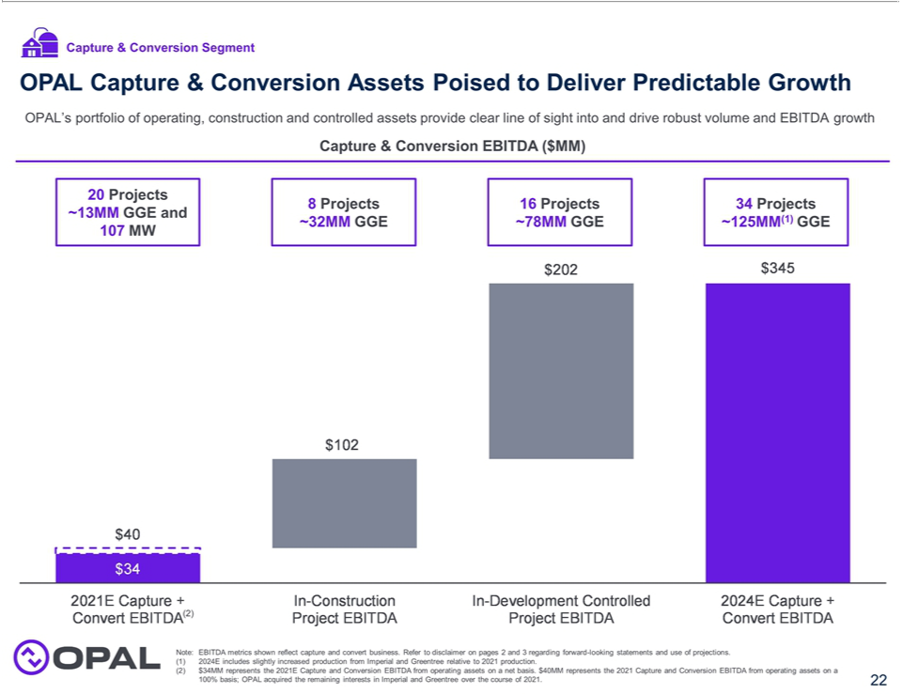

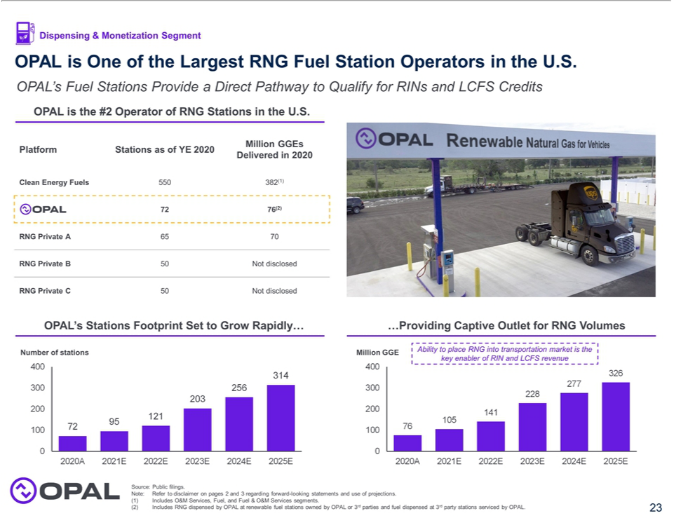

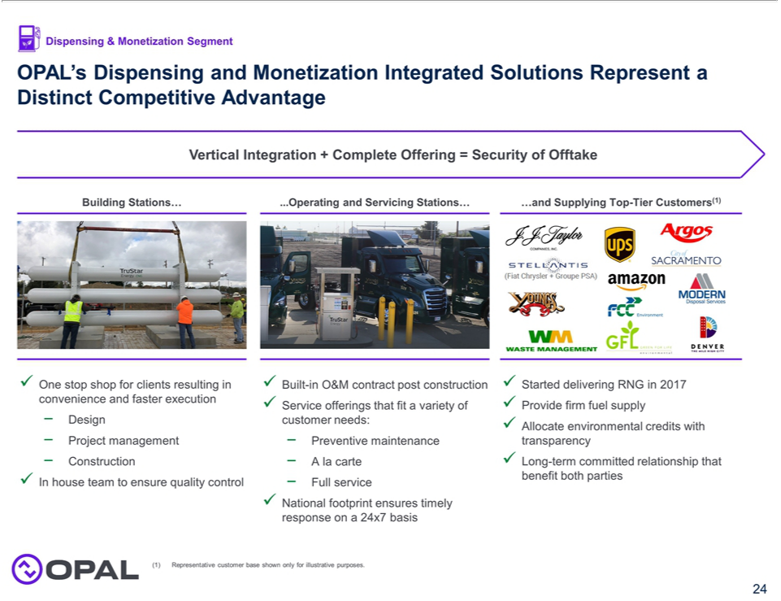

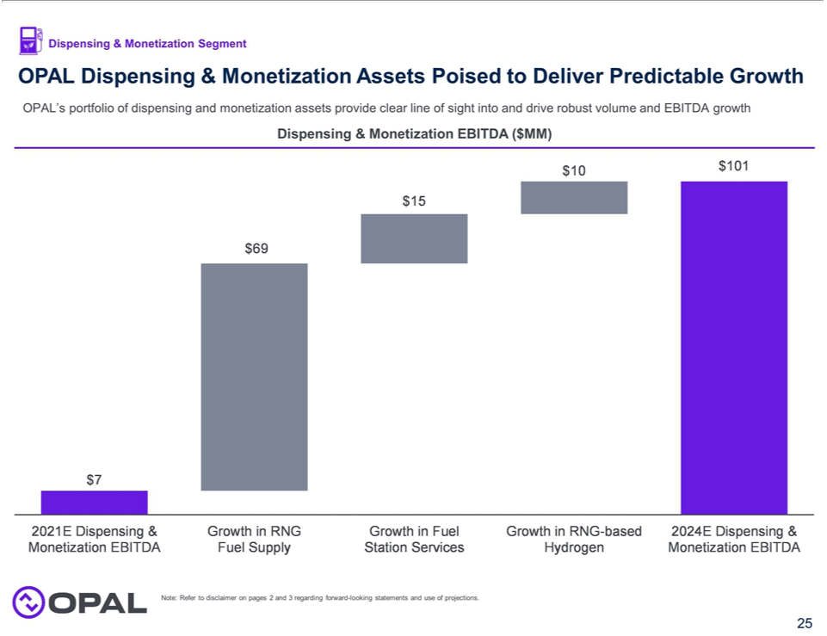

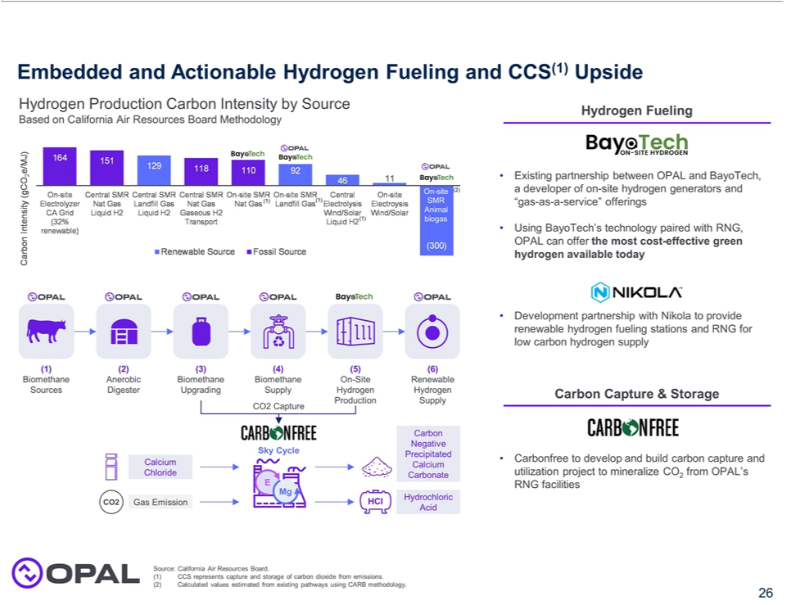



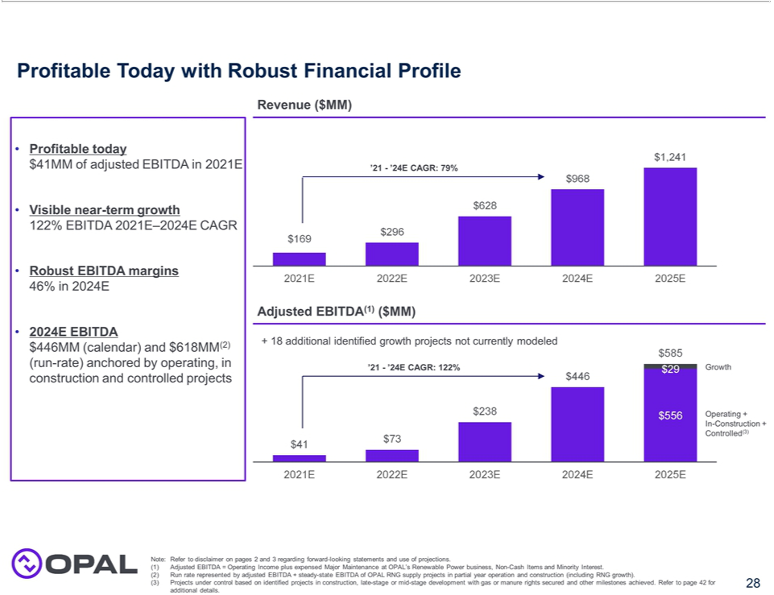

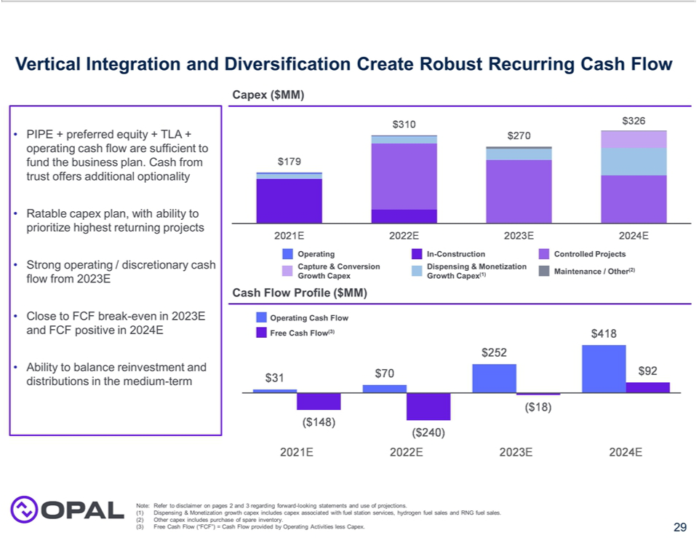



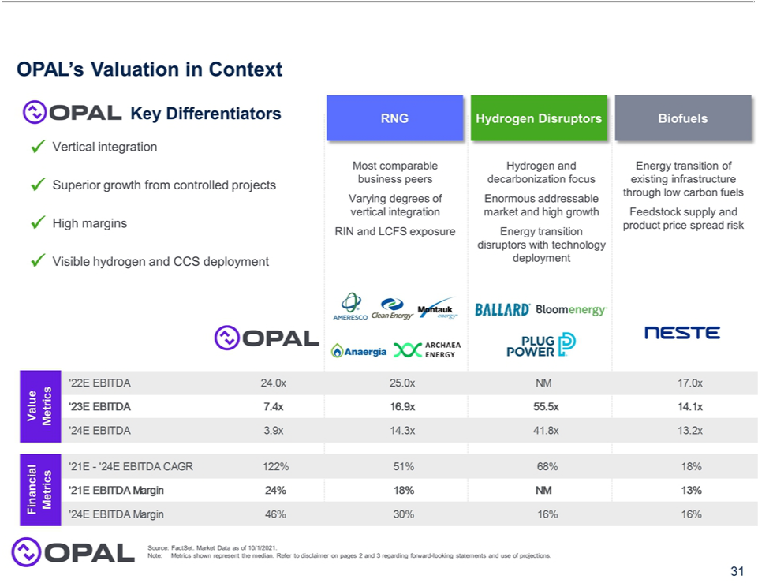

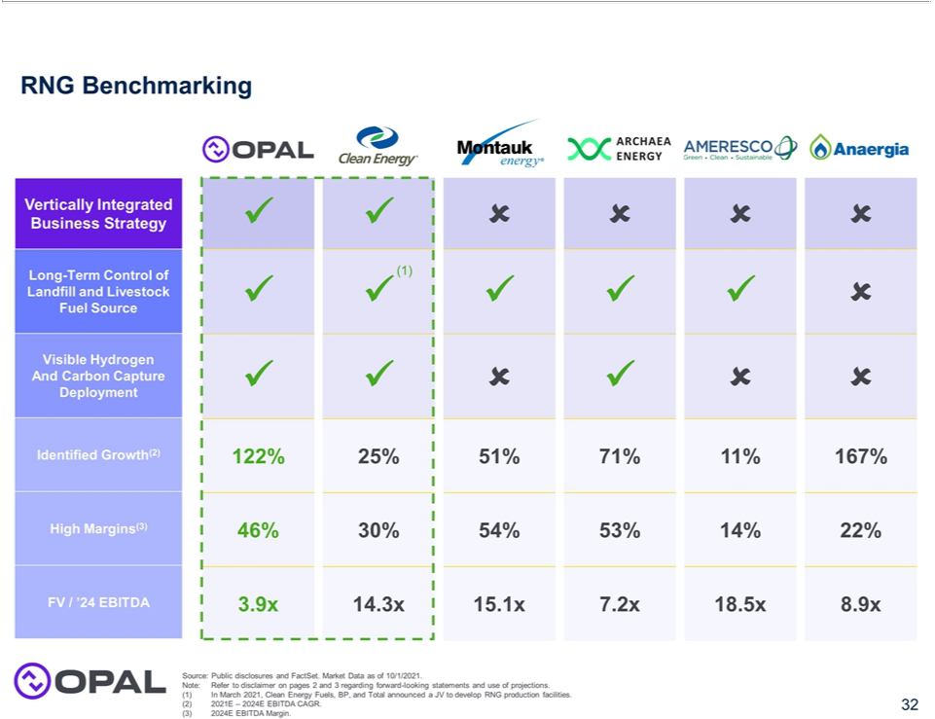

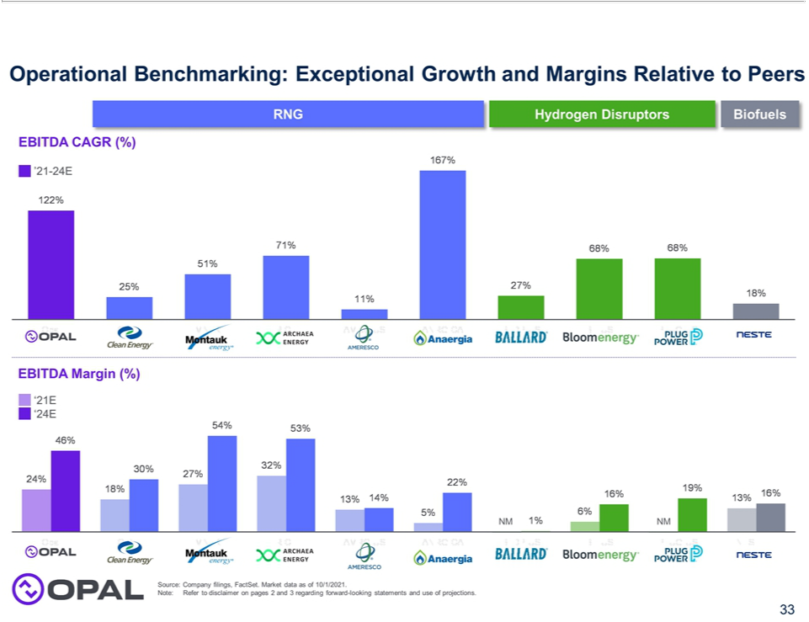

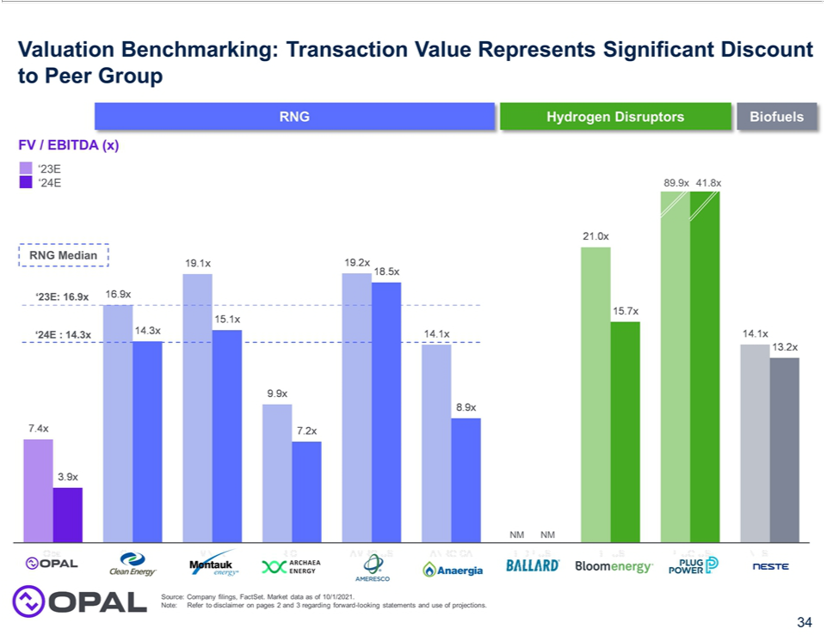

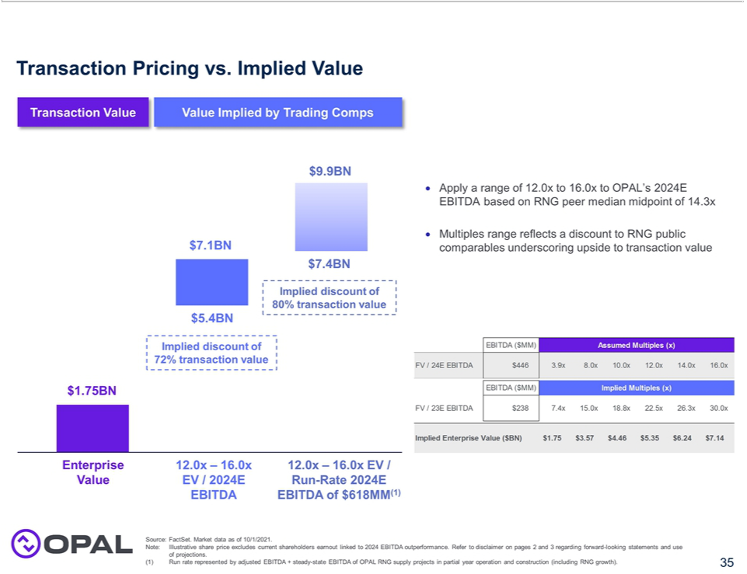

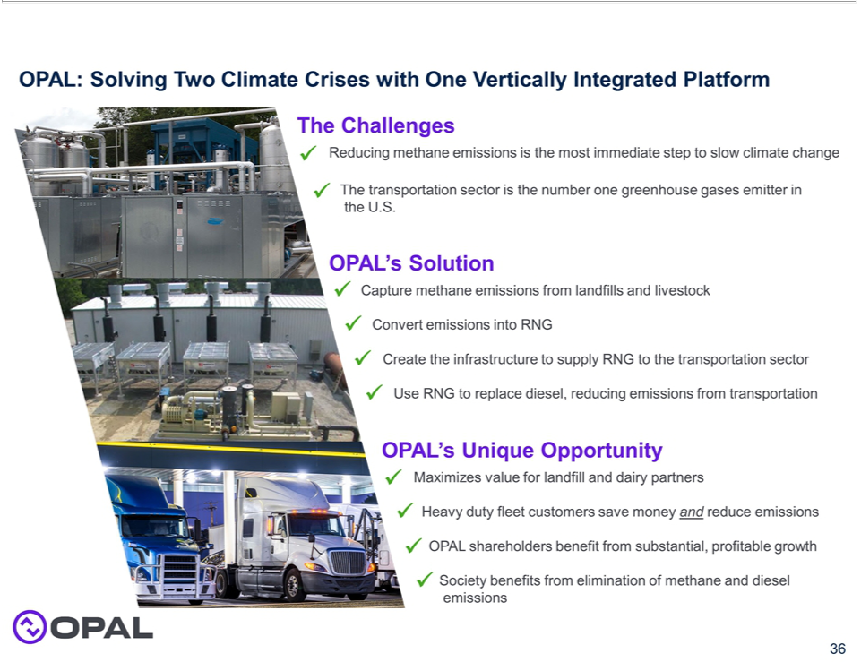



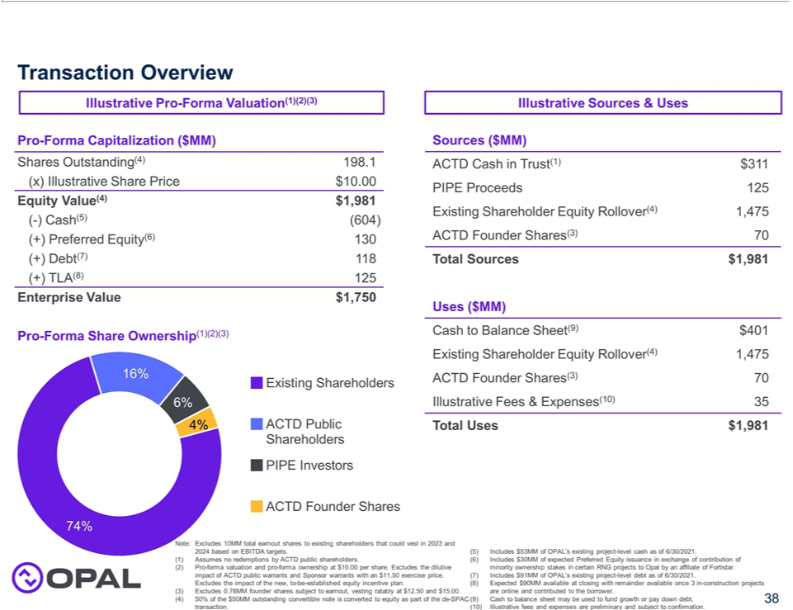

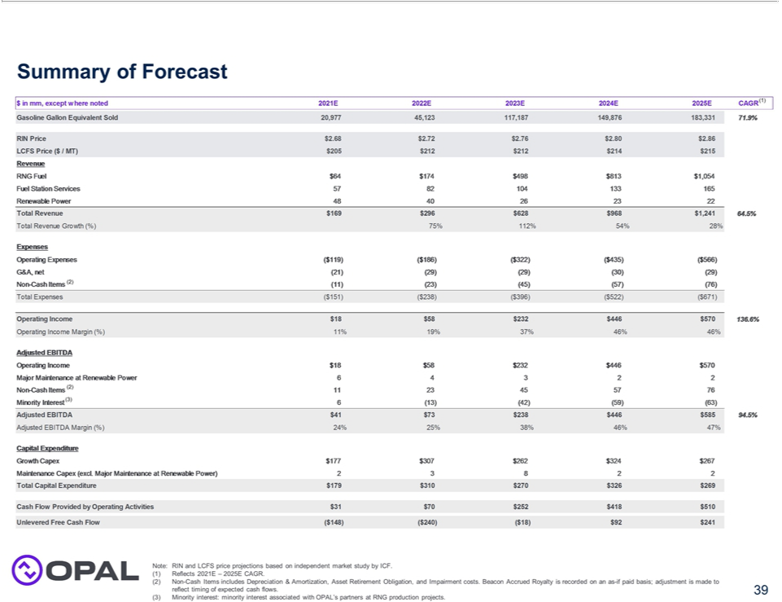

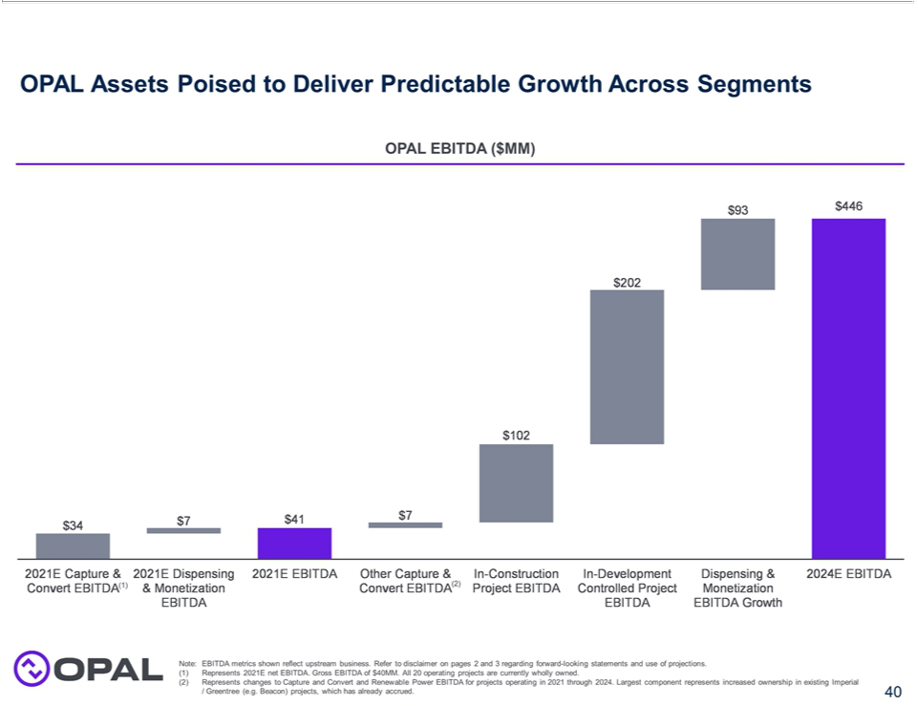

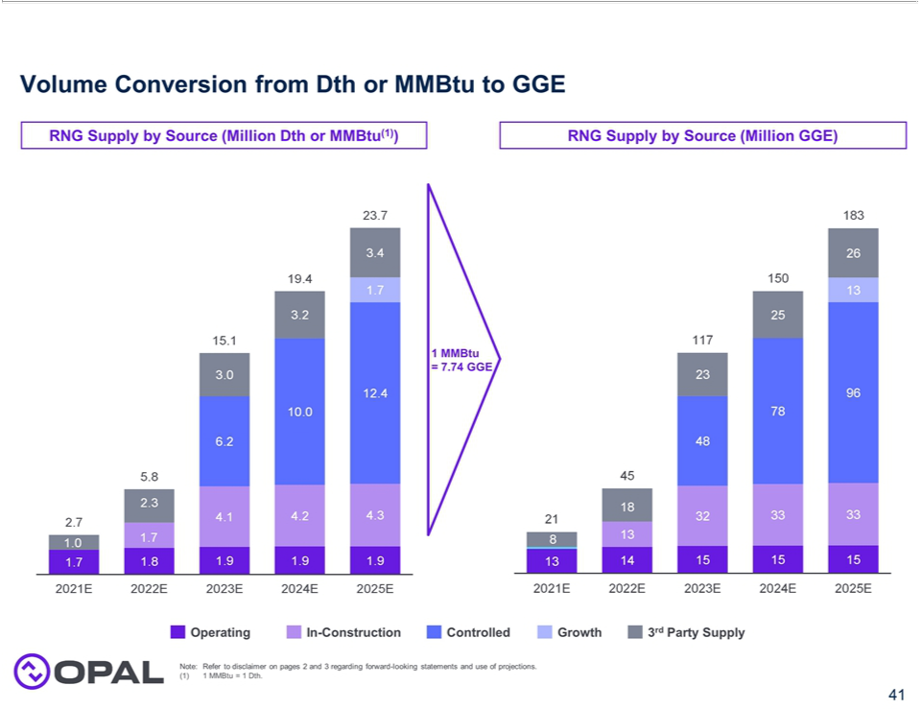

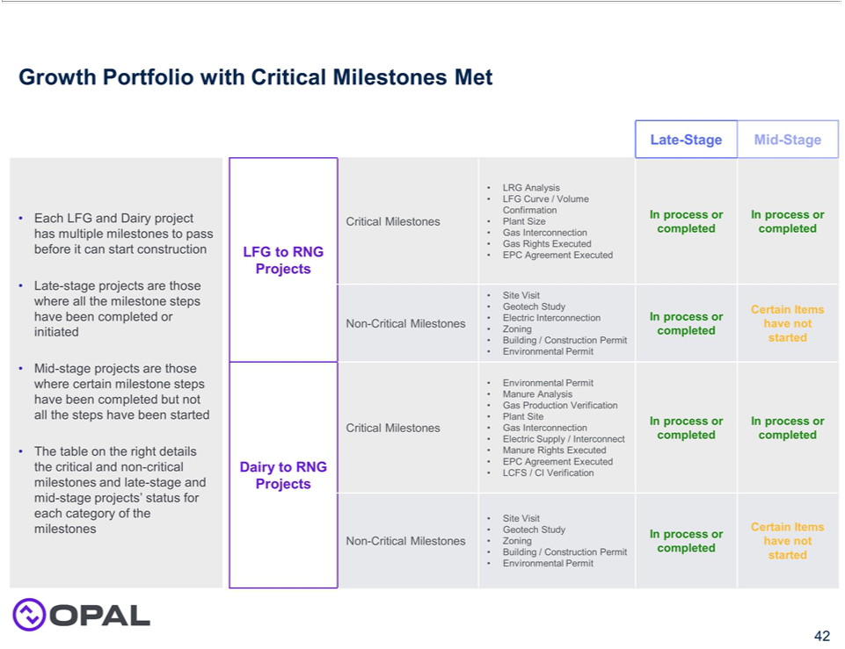

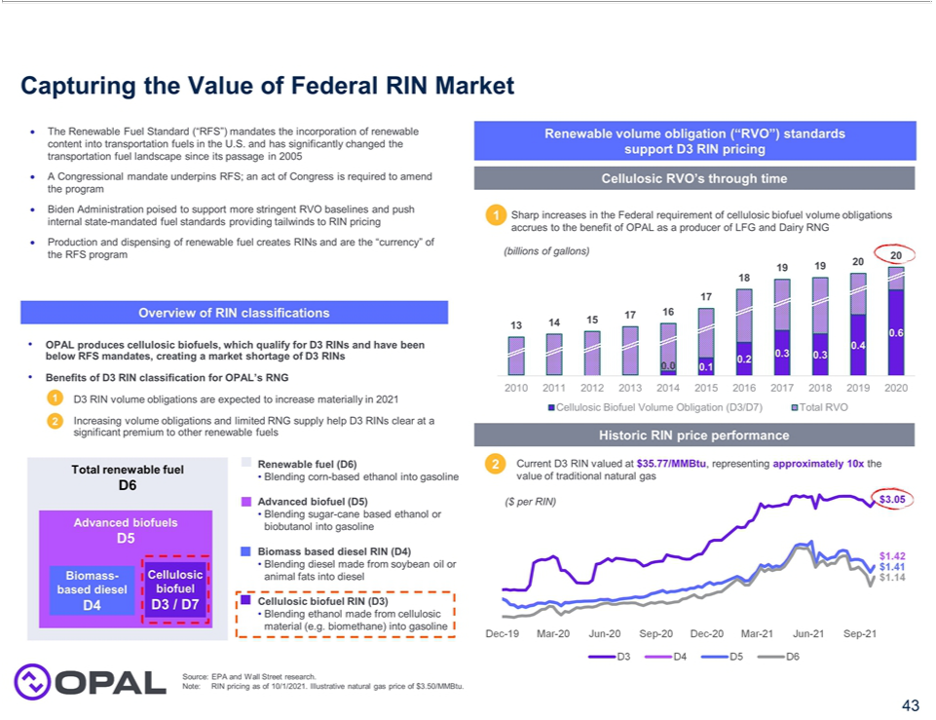

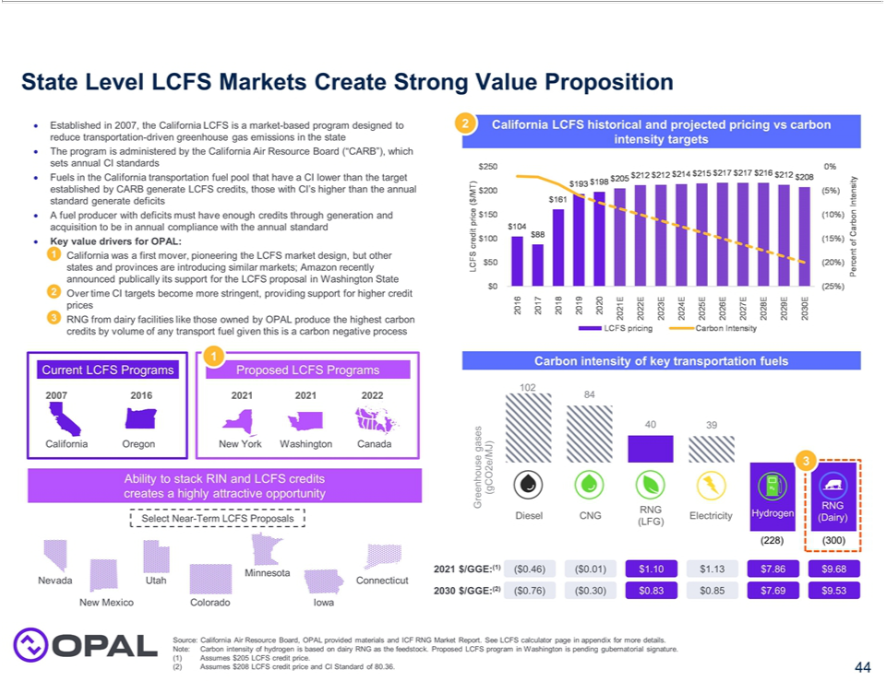

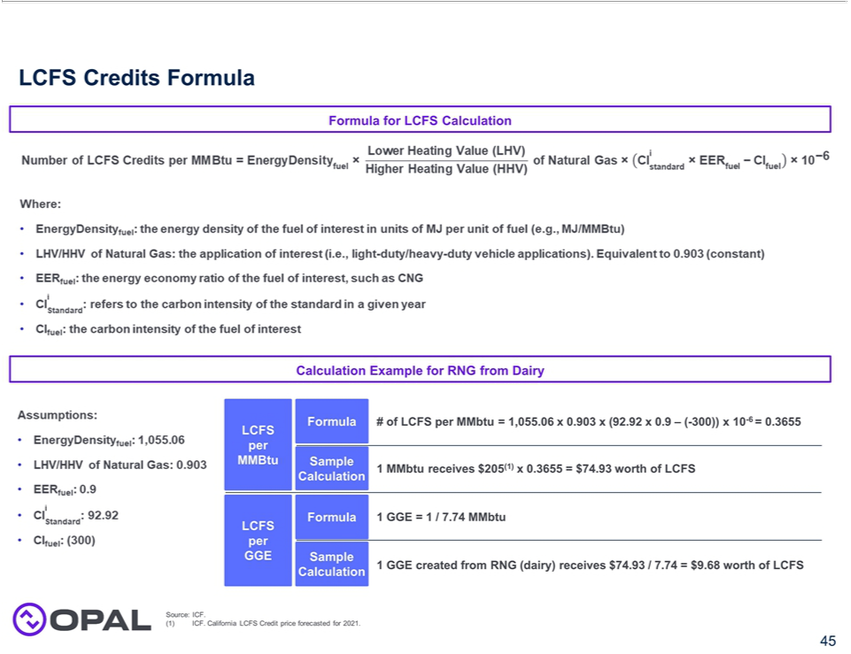

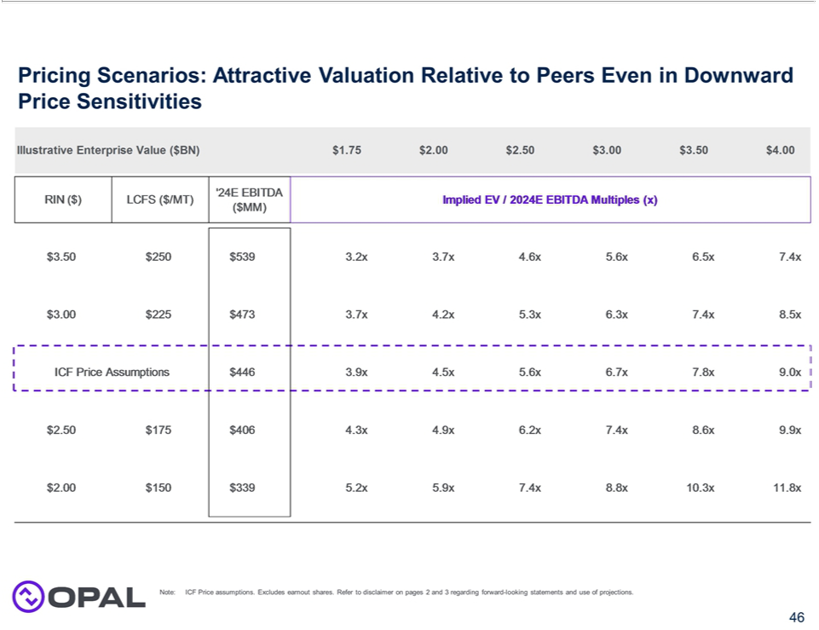

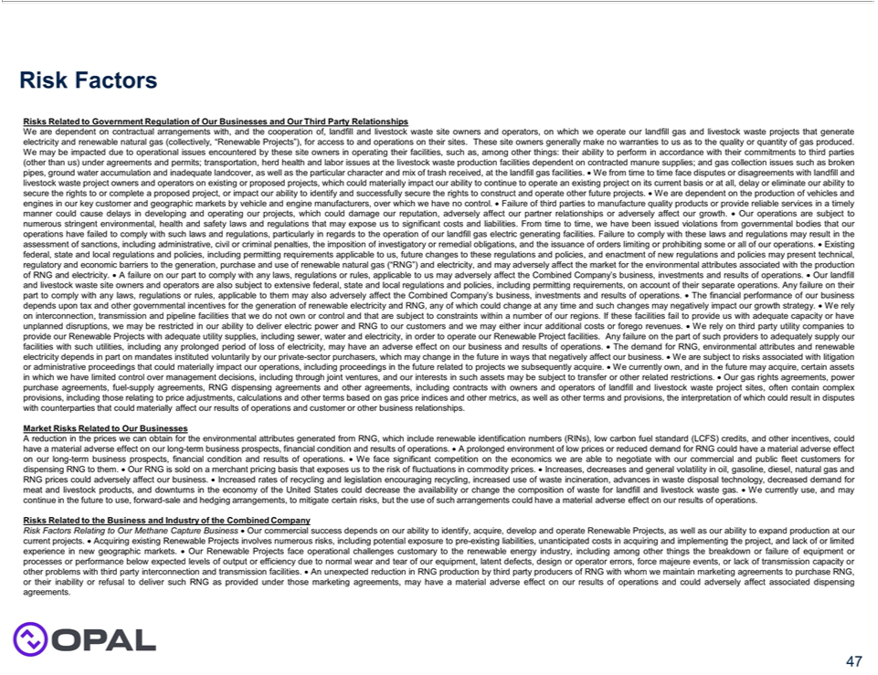

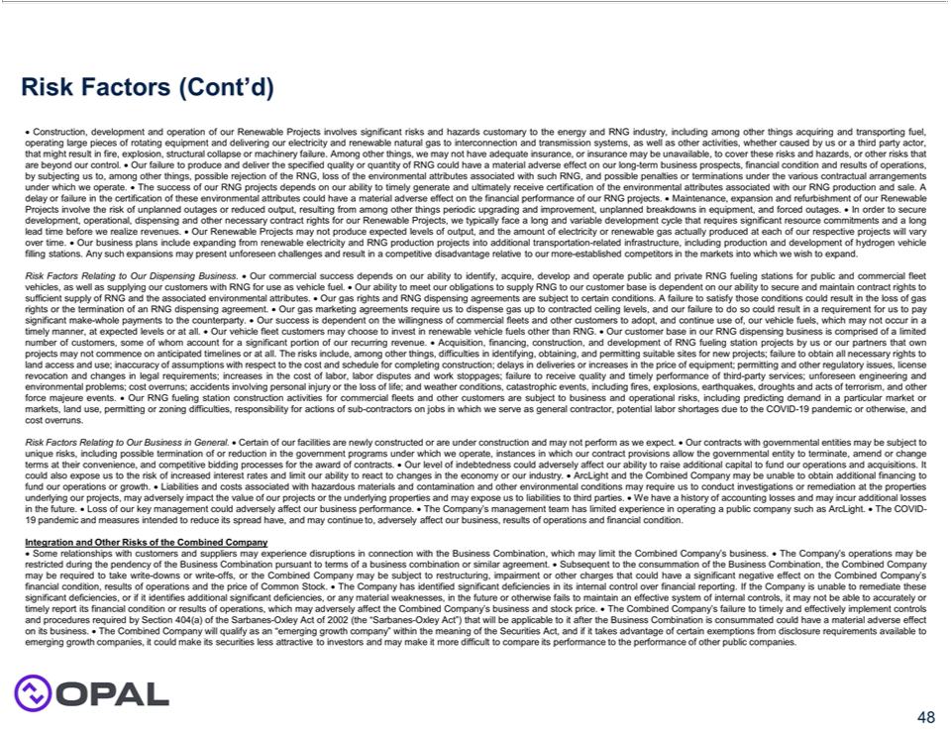

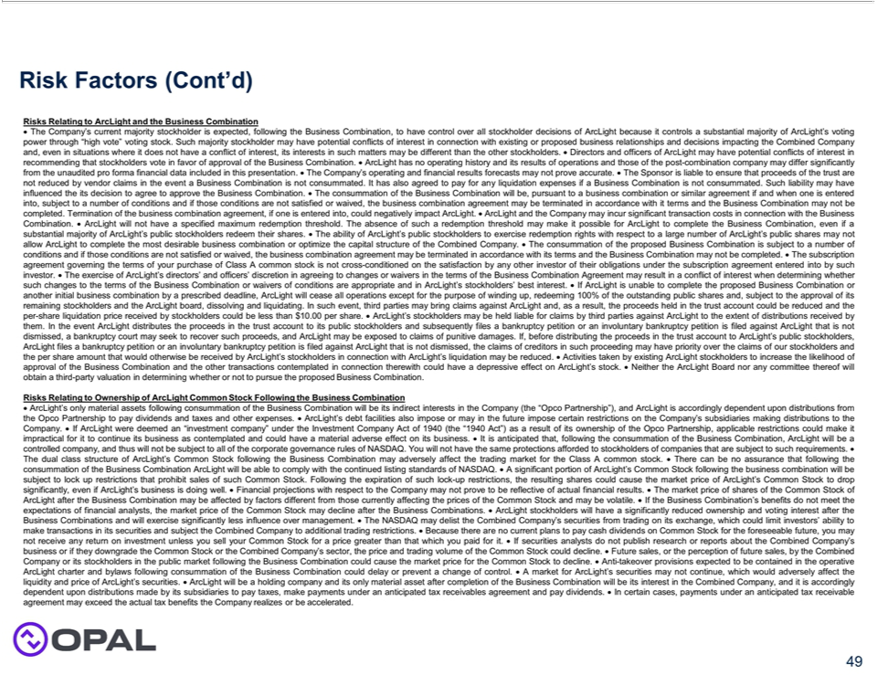

Exhibit 99.3

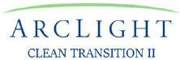

OPAL Fuels Combination with ArcLight Clean Transition Corp. II

Investor Conference Call Transcript

December 2, 2021

Operator

Welcome to the OPAL Fuels and ArcLight Clean Transition Corp. II Transaction Conference Call.

I would like to first remind everyone that this call may contain forward-looking statements including, but not limited to, OPAL Fuels, LLC and ArcLight Clean Transition Corp. II’s expectations or predictions of financial and business performance and conditions, expectations or assumptions as to product development and performance (including but not limited to the timing of development milestones), competitive and industry outlook and the timing and completion of the transaction. Forward-looking statements are inherently subject to risks, uncertainties, and assumptions and they are not guarantees of performance. Please also note that this call does not constitute or form part of an offer to issue or sell, or of a solicitation of an offer to subscribe or buy, any securities or other financial instruments, nor does it constitute a financial promotion, investment advice or an inducement to participate in any offering or investment. I encourage you to read the press release issued today, the accompanying presentation and ArcLight Clean Transition Corp. II’s filings with the SEC for a discussion of the risks that can affect the business combination, our business and the business of the combined company after completion of the proposed business combination.

I will now turn the call over to Mr. Jake Erhard. Please go ahead, sir.

Jake Erhard – President, Chief Executive Officer and Director, ArcLight Clean Transition Corp. II

Thank you, operator, and hello, everyone—we thank you for joining today’s call. My name is Jake Erhard and I am the President and Chief Executive Officer of ArcLight Clean Transition Corp. II, a Nasdaq-listed special purpose acquisition company that trades under the ticker “ACTD”. We are quite excited to announce this business combination transaction today between ArcLight and OPAL Fuels, a leading vertically integrated producer and distributor of renewable natural gas—or RNG.

ArcLight Clean Transition Corp. II is sponsored by ArcLight Capital Partners, a Boston-based energy infrastructure asset manager where I am also a Partner. ArcLight has a 20-year track record within the energy markets, having invested over $25 billion in the aggregate including over $4 billion in renewables investments since inception. We formed ACTD, our second SPAC, this past March to focus on opportunities that include renewable fuels and green hydrogen, which we see as critical enablers of a decarbonized future. OPAL Fuels is a key participant in both of these markets.

1

OPAL Fuels is a FORTISTAR portfolio company. Similar to ArcLight, FORTISTAR is an investment firm focused on growing and managing companies that target complex sustainability challenges. They have a 28-year track record of investing in independent power, renewables and storage, carbon capture, and the circular economy. They manage a portfolio of 11 companies, of which OPAL Fuels is one. OPAL Fuels was formed at the end of last year when FORTISTAR consolidated their RNG production business and their renewable transportation fuel distribution business. In so doing, FORTISTAR created what we believe is a leading platform in the renewable fuels space for two principal reasons:

- OPAL Fuels operates a vertically integrated model that differentiates it from other players in the industry, giving the company both superior margin and business capture opportunity at each point along the RNG value chain. And:

- FORTISTAR has more than 23 years of experience in this business, giving us tremendous confidence in their ability to evaluate and execute on a robust pipeline of RNG projects that they have put together and that you’ll hear more about shortly.

The end result is a company that—by executing on projects under its control—has projected a more than 10x increase in EBITDA between 2021 and 2024. I will allow the OPAL Fuels team to elaborate on all of this in a moment, but first a bit on the transaction structure.

The transaction announced today is expected to provide gross proceeds of approximately $536 million, comprised of ArcLight’s $311 million of cash held in trust, assuming no redemptions, a $125 million, fully committed common stock PIPE, and a committed $100 million preferred equity investment from NextEra Energy. The PIPE includes a $20 million investment from an affiliate of ArcLight, and a $25 million investment from NextEra Energy. NextEra is also a key strategic counterparty with investments at the asset level on several projects, and will additionally purchase and market the majority of OPAL’s environmental attributes.Following transaction closing, which is expected in the second quarter of 2022, the combined company will have a pro forma enterprise value of approximately $1.75 billion and an estimated equity value of $2.0 billion. FORTISTAR will continue to be a majority shareholder. Shares will trade on the Nasdaq under the ticker “OPL”.

We at ArcLight have always had a tremendous respect for the team at FORTISTAR given their vision, their expertise and their track record. This is reflected in the strength of the OPAL Fuels team, which starts at the top with Co-Chief Executive Officers Adam Comora and Jon Maurer, both of whom have had long careers within the FORTISTAR family and the renewable natural gas industry. So, with that, I’d like to turn the call over to Adam.

2

Adam Comora – Co-Chief Executive Officer, OPAL Fuels

Thank you, Jake, and good day to all. I would also like to express our team’s excitement about this transaction with ArcLight, which will provide OPAL Fuels with significant financial resources to fund our accelerated growth and scale our waste-to-energy, vertically integrated renewable fuels platform.

As the prior CEO of TruStar Energy, FORTISTAR’S renewable transportation fuel distribution business that Jake just touched upon, I became Co-CEO alongside Jon Maurer upon the formation of OPAL Fuels late last year when TruStar Energy merged with the FORTISTAR Methane Group and FORTISTAR’S RNG production business.

OPAL Fuels is a leading end-to-end renewable natural gas provider to the heavy-duty transportation market. With one vertically integrated platform we are addressing the two biggest challenges to halt climate change–capturing harmful methane emissions and then using that energy to reduce greenhouse gas emissions from heavy duty transportation. The transportation sector is one of the largest emitters of CO2, accounting for nearly 30% of U.S. greenhouse gas emissions each year. RNG is a scalable solution that works today using existing, proven technology in both its production and utilization in vehicles, with over 70,000 class 8 trucks on the road today. And, best of all, it saves our fleet partners money while dramatically reducing their carbon footprint. RNG is an extremely attractive renewable energy resource–it is transported over existing pipeline infrastructure and can be easily stored for when it is needed, truly a drop-in renewable resource that creates a valuable product that can help achieve sustainability goals and save our fleet customers money.

On sustainability. RNG is produced by capturing harmful, naturally occurring methane emissions from the decomposition of waste – either human or animals. When fleets transition from diesel to RNG-powered vehicles, they are able to recognize a 100 percent reduction in their Scope 1 emissions, which is an extremely powerful tool for corporations to achieve their sustainability goals.

On economics, RNG has a lower total cost of ownership than diesel, underpinned by the fact that RNG can cost 40 to 70 percent less on a per gallon equivalent basis than diesel. These annual fuel cost savings more than outweigh the additional cost of an RNG truck – providing paybacks within three years without any incentives on the vehicles. Given our track record of having developed, constructed and serviced more than 350 fuel station projects that provide reliable, diesel-like fueling for our customers, RNG has become a drop in fuel with minimal disruptions to how our customers run their business.

As a result of these RNG tailwinds, alternative fueled vehicles could see a 60-fold increase by 2040.

3

Turning to OPAL Fuels:

OPAL Fuels has historically been a renewable power company, building, owning and operating small power plants at landfills that converted the waste methane from the landfills into electricity, which was then sold under long-term power purchase agreements, or PPAs. However, over the past few years, increasing secular tailwinds, which include federal and state policy initiatives and a customer base that is increasingly focused on renewable fuels as a lever to meet their sustainability and decarbonization commitments, have supported the development of new end markets, such as transportation fuel, for our RNG assets. This brings us to today.

We are in the midst of expanding our portfolio of RNG projects, with three that are operational today and seven more that are in various stages of construction, forming the backbone of a robust project pipeline that you will hear more about in a few minutes. This transaction allows us to accelerate that conversion and capitalize on new development and acquisition opportunities to expand our production base.

At a high level, we operate under two business units—an upstream Capture and Conversion business and a downstream Dispensing and Monetization business. The Capture and Conversion business is comprised of projects that produce ultra low-carbon RNG by capturing methane emissions from landfill sites and dairy farms. The captured methane emissions are purified and treated, turning once harmful emissions into a source of clean, renewable energy. These projects are backed by long term gas rights agreements.

Our Dispensing and Monetization business delivers this clean, renewable fuel to heavy duty fleet customers through our network of fueling stations, underpinned by fueling agreements that are typically ten years in length. We also build and service fueling stations through our nationwide network across 42 states, having built more than 350 in total.

We believe that we gain economic and competitive benefits from our vertically integrated business model as we are able to capture the full value of RNG gas molecules from gas source to gas tank.

More importantly, our vertical integration provides key strategic value in growing market share with landfills and dairy farms looking to realize the most value of their resource in the transportation fuel market and with fleet customers looking for certainty of RNG supply. Specifically, diary projects require the RNG gets placed into vehicles in California and other states that provide LCFS—low carbon fuel standard—credits. We get approached by many dairy farmers and developers that first ask us for offtake agreements and then realize we can also be a good strategic partner by providing equity capital in the project, helping build and operate the facilities, and providing guidance on how best to structure the project for long term success.

We have spent some time discussing our vertical integration and how we are best positioned to capture the most value of RNG, but it is important to note that we also continue to see new end markets emerging. There are numerous voluntary markets—markets not dependent on any regulatory support —in the utility, industrial and international arena that are beginning to offer value for RNG. Some of these are offering contracts with longer terms— some as long as 15-20 years. We have not yet entered into these long-term offtake markets, yet we expect to do so once we see the value gap between these markets and the transportation fuel market close.

4

To talk more about our project pipeline, I will now turn the call over to Jon Maurer, our Co-CEO. Jon?

Jonathan Maurer – Co-Chief Executive Officer, OPAL Fuels

Thanks Adam. I have been with FORTISTAR for more than 30 years and am responsible for acquiring, developing, building and managing the upstream projects in OPAL Fuels’ upstream Capture and Conversion business, which Adam discussed. Turning to our project portfolio and pipeline.

Today, OPAL Fuels operates 21 biomethane projects. Three of these operating projects currently produce RNG fuel for sale into the transportation fuels market and the balance are currently operating as renewable power plants. Over the next several years, we expect to build 23 more RNG projects from opportunities that are substantially under our control. Many of these RNG projects will come from converting our Renewable Power projects to RNG and some will come from dairy projects that are substantially under our control today.

Right now, seven of these projects are under construction, with another 16 in the advanced development and execution phase. From these projects alone, OPAL Fuels’ EBITDA is expected to grow to $150 million. Completing the projects in advanced development, meanwhile, is expected to increase OPAL Fuels’ EBITDA to represent approximately $450 million in 2024 or more than $600 million of run rate EBITDA based on full-year operations for some projects starting in 2024.

To be clear, these are well-established projects and their execution is largely dependent on us properly “blocking and tackling”, which we have decades of experience doing. Moreover, once these projects are built, there are no significant incremental capital requirements to develop the resources.

In addition to the projects that we have in construction or advanced development, there remains additional upside potential from opportunities we see in the marketplace that we are not including in our base case projections. This includes at least 18 additional projects that are in earlier stages of development, as well as from identified M&A targets.

5

As a final point, we have our eyes on the future. We specifically have several special relationships to call out here. The first two relationships are in renewable hydrogen. BayoTech is an on-site hydrogen production and ‘gas-as-a-service’ company. We have commenced engineering and site acquisition to build several hydrogen fueling stations for BayoTech next year. In addition, we will provide RNG to lower the carbon intensity of their hydrogen fuel production. The second renewable hydrogen relationship is with Nikola, with which we have an MoU to co-develop and construct hydrogen fueling stations and related infrastructure. We will also provide RNG to Nikola’s hydrogen production partner. Lastly, we have a strategic relationship with CarbonFree to develop carbon capture facilities at several of our RNG facilities.

With that, I would now like to turn the call over to our chief financial officer, Ann Anthony. Ann?

Ann Anthony – Chief Financial Officer, OPAL Fuels

Thank you, Jon. I joined OPAL Fuels in April, and bring many years of public company experience, including roles in the utility sector and in renewable infrastructure.

Let me briefly highlight our financials before turning it back to Adam for closing remarks.

OPAL Fuels’ existing operations are expected to generate approximately $170 million in revenue and $41 million in adjusted EBITDA in 2021. These results are complemented by a robust future growth profile. Looking to the future, we anticipate the pipeline of previously identified development projects to drive an approximate 10-fold increase in adjusted EBITDA by 2024, to approximately $446 million, as referenced by Jake in his opening remarks.

By investing heavily in both our Capture and Conversion business and our Dispensing and Monetization business, we anticipate being able to create a captive outlet for the significant volumes of additional RNG production volumes, further leveraging our vertically integrated business model. Our RNG production volumes are poised to grow from 13 million GGEs in 2021 to over 125 million GGEs in 2024 through the development and construction of an additional 23 projects that are under our control. Further, an additional 25 million GGEs coming from third parties will also be dispensed. Complimenting this significant growth, our footprint of RNG fuel stations is set to expand at a CAGR of 28% between now and 2024, bringing our current estimated year end 2021 footprint of 95 stations to 256 stations.

Notably, as we execute on our identified growth plans, we anticipate OPAL Fuels to experience margin expansion, as our vertically integrated business model begins to bear greater fruit at larger scale. Our 2021 adjusted EBITDA margin is estimated at an above industry average 24%, however by controlling each point along the RNG production and distribution value chain, we target our 2024 adjusted EBITDA margin to expand to 46%.

Before concluding, let me touch on the expected funding from this transaction compared with our capital needs. Between the potential $536 million raised from this transaction and a $125 million term loan we secured in October plus operating cash flow generated by the business, we believe that we have enough resources to fund our business, including all projects in construction and advanced development. Proceeds from the transaction would also provide optionality to participate in M&A opportunities or other earlier stage development projects that are not in the current plan today.

6

For additional information, we encourage you to review our investor presentation that was released along with the other transaction-related materials earlier this morning. I will now turn it back to Adam for closing remarks.

Adam Comora – Co-Chief Executive Officer, OPAL Fuels

Thanks Ann. It is clear that the world needs an all-hands-on-deck approach to decarbonization. With the U.S. transportation sector being one of the largest emitters of CO2, alternative fuels will play a critical role in decarbonization. OPAL Fuels is the U.S.’s leading end-to-end renewable natural gas provider to the heavy-duty transportation market. With RNG, there does not need to be a tradeoff between doing what’s best for your business and doing what’s best for the planet. RNG is an extremely rare product that can both save our fleet customers money and dramatically reduce their carbon footprint. Our more than two decades of experience in this area has positioned us well to remain a leading platform in the production and distribution of renewable fuels, and our vertically integrated model provides us with differentiated economic and competitive benefits. We look forward to transitioning to the public market, blocking and tacking on our existing robust RNG project pipeline and taking advantage of the significant M&A and additional development partnerships we see coming that will dramatically scale our business over the coming years.

Thank you very much and have a great day.

Operator

That concludes today’s conference call. Thank you, you may now disconnect.

7

Forward-Looking Statements

Certain statements in this communication may be considered forward-looking statements. Forward-looking statements are statements that are not historical facts and generally relate to future events or ArcLight’s or OPAL Fuels’ (the “Company’s”) future financial or other performance metrics. In some cases, you can identify forward-looking statements by terminology such as “believe,” “may,” “will,” “potentially,” “estimate,” “continue,” “anticipate,” “intend,” “could,” “would,” “project,” “target,” “plan,” “expect,” or the negatives of these terms or variations of them or similar terminology. Such forward-looking statements, including the identification of a target business and a potential business combination or other such transaction are subject to risks and uncertainties, which could cause actual results to differ materially from those expressed or implied by such forward looking statements. New risks and uncertainties may emerge from time to time, and it is not possible to predict all risks and uncertainties. These forward-looking statements are based upon estimates and assumptions that, while considered reasonable by ArcLight and its management, and the Company and its management, as the case may be, are inherently uncertain and subject to material change. Factors that may cause actual results to differ materially from current expectations include, but are not limited to, various factors beyond management’s control, including general economic conditions and other risks, uncertainties and factors set forth in the section entitled “Risk Factors” and “Cautionary Note Regarding Forward-Looking Statements” in ArcLight’s final prospectus relating to its initial public offering, dated September 22, 2020, and other filings with the Securities and Exchange Commission (SEC), including the registration statement on Form S-4 to be filed by ArcLight in connection with the transaction, as well as

- the inability to complete the proposed transaction; (2) factors associated with companies, such as the Company, that are engaged in the production and integration of renewable natural gas (RNG), including anticipated trends, growth rates, and challenges in those businesses and in the markets in which they operate; (3) macroeconomic conditions related to the global COVID-19 pandemic; (4) the effects of increased competition; (5) contractual arrangements with, and the cooperation of, landfill and livestock waste site owners and operators, on which the Company operates its landfill gas and livestock waste projects that generate electricity and RNG prices for environmental attributes, low carbon fuel standard credits and other incentives;
- the ability to identify, acquire, develop and operate renewable projects and RNG fueling stations; (7) the failure to realize the anticipated benefits of the proposed transaction, which may be affected by, among other things, competition, the ability of the combined company to grow and manage growth profitably, maintain relationships with customers and suppliers and retain key employees; (8) delays in obtaining, adverse conditions contained in, or the inability to obtain necessary regulatory approvals or complete regulatory reviews required to complete the proposed transaction; (9) the outcome of any legal proceedings that may be instituted in connection with the proposed transaction; (10) the amount of redemption requests made by ArcLight’s public shareholders; and (11) the ability of the combined company that results from the proposed transaction to issue equity or equity-linked securities or obtain debt financing in connection with the transaction or in the future. Nothing in this communication should be regarded as a representation by any person that the forward-looking statements set forth herein will be achieved or that any of the contemplated results of such forward-looking statements will be achieved. You should not place undue reliance on forward-looking statements in this communication, which speak only as of the date they are made and are qualified in their entirety by reference to the cautionary statements herein. Both ArcLight and the Company expressly disclaim any obligations or undertaking to release publicly any updates or revisions to any forward-looking statements contained herein to reflect any change in ArcLight’s or the Company’s expectations with respect thereto or any change in events, conditions or circumstances on which any statement is based.

8

Important Information and Where to Find It

A full description of the terms of the transaction will be provided in a registration statement on Form S-4 to be filed with the SEC by ArcLight that will include a prospectus with respect to the combined company’s securities to be issued in connection with the business combination and a proxy statement with respect to the shareholders meeting of ArcLight to vote on the business combination. ArcLight urges its investors, shareholders and other interested persons to read, when available, the preliminary proxy statement/prospectus as well as other documents filed with the SEC because these documents will contain important information about ArcLight, the Company and the transaction. After the registration statement is declared effective, the definitive proxy statement/prospectus to be included in the registration statement will be mailed to shareholders of ArcLight as of a record date to be established for voting on the proposed business combination. Once available, shareholders will also be able to obtain a copy of the S-4, including the proxy statement/prospectus, and other documents filed with the SEC without charge, by directing a request to: ArcLight Clean Transition Corp. II, 200 Clarendon Street, 55th Floor, Boston, Massachusetts 02116. The preliminary and definitive proxy statement/prospectus to be included in the registration statement, once available, can also be obtained, without charge, at the SEC’s website (www.sec.gov).

Participants in the Solicitation

ArcLight and the Company and their respective directors and officers may be deemed to be participants in the solicitation of proxies from ArcLight’s shareholders in connection with the proposed transaction. Information about ArcLight’s directors and executive officers and their ownership of ArcLight’s securities is set forth in ArcLight’s filings with the SEC. To the extent that holdings of ArcLight’s securities have changed since the amounts printed in ArcLight’s Registration Statement on Form S-1, such changes have been or will be reflected on Statements of Change in Ownership on Form 4 filed with the SEC. Additional information regarding the interests of those persons and other persons who may be deemed participants in the proposed transaction may be obtained by reading the proxy statement/consent solicitation statement/prospectus regarding the proposed transaction when it becomes available. You may obtain free copies of these documents as described in the preceding paragraph.

Non-Solicitation

This communication is not a proxy statement or solicitation of a proxy, consent or authorization with respect to any securities or in respect of the potential transaction and shall not constitute an offer to sell or a solicitation of an offer to buy the securities of ArcLight, the Company or the combined company, nor shall there be any sale of any such securities in any state or jurisdiction in which such offer, solicitation, or sale would be unlawful prior to registration or qualification under the securities laws of such state or jurisdiction. No offer of securities shall be made except by means of a prospectus meeting the requirements of the Securities Act.

9

